Contents

1) Introduction – 2 min 2

1.1.) Anaconda 3

1.2.) PyPI 3

1.3.) Virtual Environment 4

1.4.) Conda 4

1.5.) Package manager 5

1.6.) Package format 5

1.7.) Software package 5

1.8.) Conda channels 6

1.9.) Software repository 6

1.10.) PIP 6

1.11) Cross-platform 6

1.12.) Metadata 7

2) Instalation – 9 min 8

3) Python Crash Course – 2h 10 min 9

2.2.) Varijable 9

2.3.) Metode 14

2.4.) Liste 15

2.4.1) Sequence 16

2.4.2.) Slicing 16

2.5.) Membership operators 16

2.6.) Often Used Functions in Python 17

2.7.) Tuples 18

2.8.) Sets 19

2.9.) Dictinaoris 19

2.10.) Kombinacija 20

2.11.) Sintaksa izjava i petlji 20

2.11.1.) if-else 20

2.11.2. elif 21

2.11.3. for 22

2.11.4. While 23

2.12.) Funkcije 23

2.13.) Klase 29

4) NumPy Crash Course – 1h 6 min 30

4.2.) Arrays vs. Lists 30

4.3.) Slicing 33

4.4.) Reshaping 34

4.5.) Slicing 35

5) Computer Vision: Finding Lane Lines – 1h 23 min 40

6) The Perceptron – 1h 31 min 59

7) Keras 60

8) Deep Neural Networks 101 – 44 min 67

9) Multiclass Classification – 53 min 68

10) MNIST Image Recognition – 1h 34 min 71

11) Convolutional Neural Networks 73

12) Classifying Road Symbols – 1h 53 min 76

13) Polynomial Regression - 17 min 79

14) Behavioural Cloning 79

# 1) Introduction – 2 min

Svijetlo Plavi marker – Naslovi razine 1 .

Ljubičasti Marker – Naslovi razine 2.

Maslinasto Zeleni Marker – Naslovi razine 3.

Žuti Marker – Važan Tekst

Zeleni Marker – CMD Naredbe i kod

**__________________________________________________________**

1.1.) Anaconda

**Anaconda** is a [free and open-source](https://en.wikipedia.org/wiki/Free_and_open-source)[[5]](https://en.wikipedia.org/wiki/Anaconda_(Python_distribution)#cite_note-5) distribution of the [Python](https://en.wikipedia.org/wiki/Python_(programming_language)) and [R](https://en.wikipedia.org/wiki/R_(programming_language)) programming languages for [scientific computing](https://en.wikipedia.org/wiki/Scientific_computing) ([data science](https://en.wikipedia.org/wiki/Data_science), [machine learning](https://en.wikipedia.org/wiki/Machine_learning) applications, large-scale data processing, [predictive analytics](https://en.wikipedia.org/wiki/Predictive_analytics), etc.), that aims to simplify [package management](https://en.wikipedia.org/wiki/Package_management) and deployment.

**Anaconda distribution** comes with 1,500 packages selected from [**PyPI**](https://en.wikipedia.org/wiki/Python_Package_Index) as well as the [**conda**](https://en.wikipedia.org/wiki/Conda_(package_manager)) package and [**virtual environment manager**](https://www.pythonforbeginners.com/basics/how-to-use-python-virtualenv/). It also includes a GUI, **Anaconda Navigator**[[7]](https://en.wikipedia.org/wiki/Anaconda_(Python_distribution)#cite_note-7), as a graphical alternative to the command line interface (CLI).

**Anaconda Navigator** is a desktop graphical user interface (GUI) included in Anaconda® distribution that allows you to launch applications and easily manage conda [**packages**](https://en.wikipedia.org/wiki/Package_format), [**environments**](https://www.pythonforbeginners.com/basics/how-to-use-python-virtualenv/), and [**channels**](https://docs.conda.io/projects/conda/en/latest/user-guide/concepts/channels.html) without using command-line commands. Navigator can search for packages on Anaconda Cloud or in a local Anaconda Repository. It is available for Windows, macOS, and Linux. 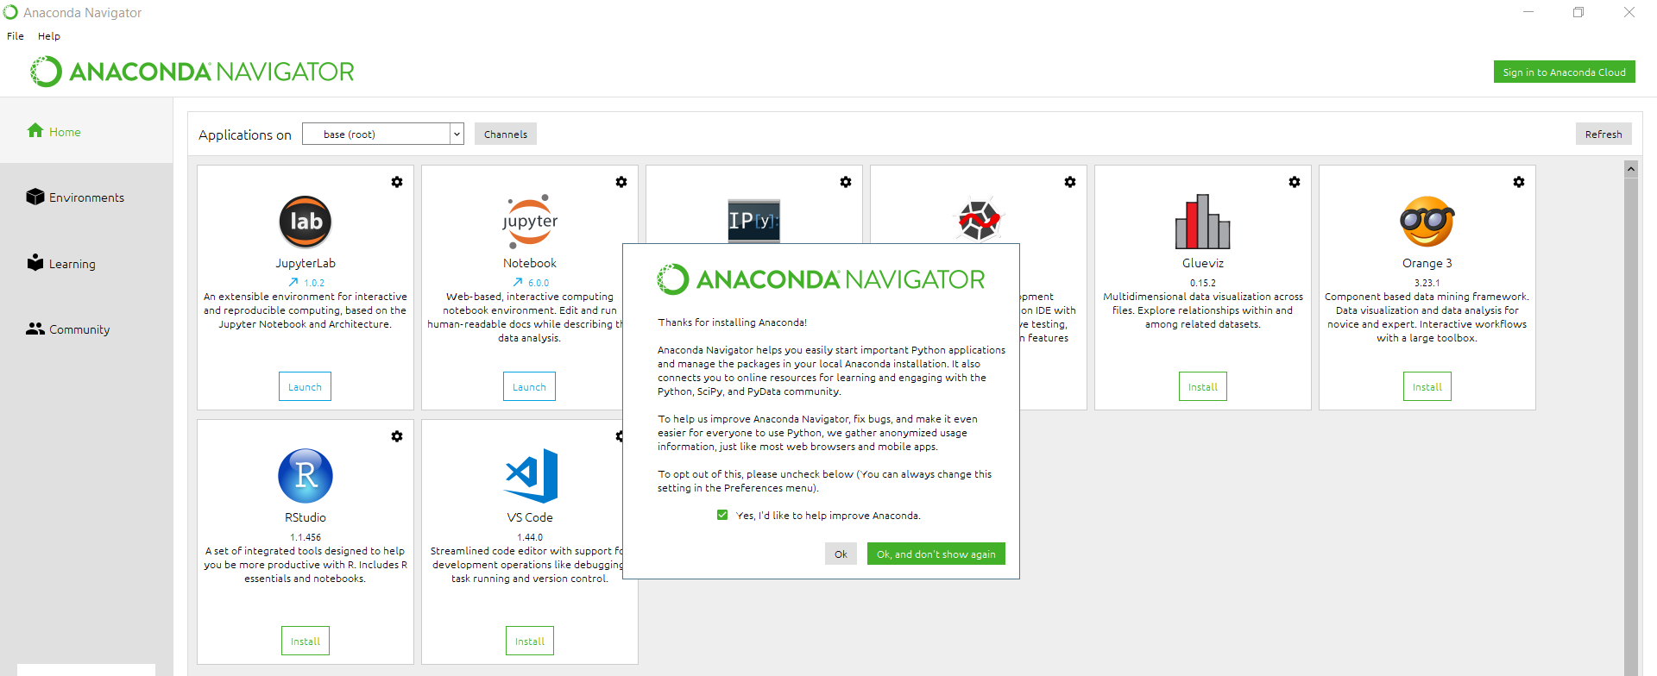

**__________________________________________________________**

1.2.) PyPI

**PyPI** The **Python Package Index**, abbreviated as **PyPI** and also known as the **Cheese Shop** (a reference to the [*Monty Python's Flying Circus*](https://en.wikipedia.org/wiki/Monty_Python%27s_Flying_Circus) sketch "[Cheese Shop](https://en.wikipedia.org/wiki/Cheese_Shop_sketch)"),[[1]](https://en.wikipedia.org/wiki/Python_Package_Index#cite_note-FOOTNOTELutz20068-1)[[2]](https://en.wikipedia.org/wiki/Python_Package_Index#cite_note-FOOTNOTERamalho2015742-2) is the official third-party [**software repository**](https://en.wikipedia.org/wiki/Software_repository) for [Python](https://en.wikipedia.org/wiki/Python_(programming_language)).[[3]](https://en.wikipedia.org/wiki/Python_Package_Index#cite_note-ancient_pypi_tutorial-3) It is analogous to [CPAN](https://en.wikipedia.org/wiki/CPAN), the repository for [Perl](https://en.wikipedia.org/wiki/Perl).[[4]](https://en.wikipedia.org/wiki/Python_Package_Index#cite_note-FOOTNOTEBarry201036-4) Some package managers, including [**pip**](https://en.wikipedia.org/wiki/Pip_(Python)), use PyPI as the default source for packages and their dependencies.[[5]](https://en.wikipedia.org/wiki/Python_Package_Index#cite_note-pip_usage-5)[[6]](https://en.wikipedia.org/wiki/Python_Package_Index#cite_note-pypi_mirrors-6) Over 113,000 Python packages can be accessed through PyPI.[[7]](https://en.wikipedia.org/wiki/Python_Package_Index#cite_note-pypi_home-7)

PyPI primarily hosts Python packages in the form of archives called sdists (source distributions) or precompiled "wheels."[[8]](https://en.wikipedia.org/wiki/Python_Package_Index#cite_note-wheel_pep-8)

PyPI as an index allows users to search for packages by keywords or by filters against their **metadata**, such as [free software license](https://en.wikipedia.org/wiki/Free_software_license) or compatibility with [POSIX](https://en.wikipedia.org/wiki/POSIX).[[9]](https://en.wikipedia.org/wiki/Python_Package_Index#cite_note-pypi_browse-9) A single entry on PyPI is able to store, aside from just a package and its metadata, previous releases of the package, precompiled wheels (e.g. containing [DLLs](https://en.wikipedia.org/wiki/Dynamic-link_library) on Windows), as well as different forms for different operating systems and Python versions.

**__________________________________________________________**

## 1.3.) Virtual Environment

**A Virtual Environment**, put simply, is an isolated working copy of Python which allows you to work on a specific project without worry of affecting other projects. It enables multiple side-by-side installations of Python, one for each project. It doesn’t actually install separate copies of Python, but it does provide a clever way to keep different project environments isolated.

**__________________________________________________________**

## 1.4.) Conda

**Conda** is an [open-source](https://en.wikipedia.org/wiki/Open-source_software),[[1]](https://en.wikipedia.org/wiki/Conda_(package_manager)#cite_note-conda.pydata-1) [cross-platform](https://en.wikipedia.org/wiki/Cross-platform),[[2]](https://en.wikipedia.org/wiki/Conda_(package_manager)#cite_note-pydanny-2) [language-agnostic](https://en.wikipedia.org/wiki/Language-agnostic) [package manager](https://en.wikipedia.org/wiki/Package_manager) and environment management system. It was originally developed to solve difficult package management challenges faced by [Python](https://en.wikipedia.org/wiki/Python_(programming_language)) [data scientists](https://en.wikipedia.org/wiki/Data_science), and today is a popular package manager for Python and [R](https://en.wikipedia.org/wiki/R_(programming_language)).[[3]](https://en.wikipedia.org/wiki/Conda_(package_manager)#cite_note-3)[[4]](https://en.wikipedia.org/wiki/Conda_(package_manager)#cite_note-networkworld-Jackson-DARPA-4) It is released under the [BSD license](https://en.wikipedia.org/wiki/BSD_licenses) by Anaconda Inc.[[1]](https://en.wikipedia.org/wiki/Conda_(package_manager)#cite_note-conda.pydata-1)[[5]](https://en.wikipedia.org/wiki/Conda_(package_manager)#cite_note-penandpants-5)[[6]](https://en.wikipedia.org/wiki/Conda_(package_manager)#cite_note-data-science-6)[[7]](https://en.wikipedia.org/wiki/Conda_(package_manager)#cite_note-python-prog-7)[[8]](https://en.wikipedia.org/wiki/Conda_(package_manager)#cite_note-python-8)[[9]](https://en.wikipedia.org/wiki/Conda_(package_manager)#cite_note-yf-conda-9)

The big difference between conda and the [**pip package manager**](https://en.wikipedia.org/wiki/Pip_(package_manager))is in how package dependencies are managed, which is a significant challenge for Python data science and the reason conda exists.

When pip installs a package, it automatically installs any dependent Python packages without checking if these conflict with previously installed packages[[*citation needed*](https://en.wikipedia.org/wiki/Wikipedia:Citation_needed)]. It will install a package and any of its dependencies regardless of the state of the existing installation[[*citation needed*](https://en.wikipedia.org/wiki/Wikipedia:Citation_needed)]. Because of this, a user with a working installation of, for example, Google Tensorflow, can find that it stops working having used pip to install a different package that requires a different version of the dependent **numpy library** than the one used by Tensorflow. In some cases, the package may appear to work but produce different results in detail.

In contrast, conda analyses the current environment including everything currently installed, and, together with any version limitations specified (e.g. the user may wish to have Tensorflow version 2,0 or higher), works out how to install a compatible set of dependencies, and shows a warning if this cannot be done.

Open source packages can be individually installed from the Anaconda repository[[8]](https://en.wikipedia.org/wiki/Anaconda_(Python_distribution)#cite_note-AnacondaRepo-8), Anaconda Cloud (anaconda.org), or your own private repository or mirror, using the **conda install** command. Anaconda Inc compiles and builds the packages available in the Anaconda repository itself, and provides binaries for Windows 32/64 bit, Linux 64 bit and MacOS 64-bit. Anything available on [PyPI](https://en.wikipedia.org/wiki/Python_Package_Index) may be installed into a conda environment using pip, and conda will keep track of what it has installed itself and what pip has installed.

Custom packages can be made using the **conda build** command, and can be shared with others by uploading them to Anaconda Cloud,[[9]](https://en.wikipedia.org/wiki/Anaconda_(Python_distribution)#cite_note-AnacondaCloud-9) [PyPI](https://en.wikipedia.org/wiki/Python_Package_Index) or other repositories.

The default installation of Anaconda2 includes Python 2.7 and Anaconda3 includes Python 3.7. However, it is possible to create new environments that include any version of Python packaged with conda[[10]](https://en.wikipedia.org/wiki/Anaconda_(Python_distribution)#cite_note-10).

**__________________________________________________________**

## 1.5.) Package manager

**A package manager** or **package-management system** is a collection of software tools that automates the process of installing, upgrading, configuring, and removing computer programs for a [computer](https://en.wikipedia.org/wiki/Computer)'s [operating system](https://en.wikipedia.org/wiki/Operating_system) in a consistent manner.

A package manager deals with [*packages*](https://en.wikipedia.org/wiki/Package_format), distributions of software and data in [archive files](https://en.wikipedia.org/wiki/Archive_file). Packages contain [metadata](https://en.wikipedia.org/wiki/Metadata), such as the software's name, description of its purpose, version number, vendor, [checksum](https://en.wikipedia.org/wiki/Checksum) (preferably a [cryptographic hash function](https://en.wikipedia.org/wiki/Cryptographic_hash_function)), and a list of [dependencies](https://en.wikipedia.org/wiki/Coupling_(computer_programming)) necessary for the software to run properly. Upon installation, metadata is stored in a local package database. Package managers typically maintain a database of software dependencies and version information to prevent software mismatches and missing prerequisites. They work closely with [software repositories](https://en.wikipedia.org/wiki/Software_repository), [binary repository managers](https://en.wikipedia.org/wiki/Binary_repository_manager), and [app stores](https://en.wikipedia.org/wiki/App_store).

Package managers are designed to eliminate the need for manual installs and updates. This can be particularly useful for large enterprises whose operating systems are based on [Linux](https://en.wikipedia.org/wiki/Linux) and other [Unix-like](https://en.wikipedia.org/wiki/Unix-like) systems, typically consisting of hundreds or even tens of thousands of distinct software packages.[[2]](https://en.wikipedia.org/wiki/Package_manager#cite_note-2)

**__________________________________________________________**

## 1.6.) Package format

**A package format** is a type of [archive](https://en.wikipedia.org/wiki/Archive_file) containing computer programs and additional metadata needed by [package managers](https://en.wikipedia.org/wiki/Package_manager).[[1]](https://en.wikipedia.org/wiki/Package_format#cite_note-1) While the [archive file format](https://en.wikipedia.org/wiki/Archive_file_format) itself may be unchanged, package formats bear additional metadata, such as a [manifest file](https://en.wikipedia.org/wiki/Manifest_file) or certain directory layouts. Packages may contain either source code or [executable files](https://en.wikipedia.org/wiki/Executable_files).

Packages may be converted from one type to another with software such as [Alien](https://en.wikipedia.org/wiki/Alien_(file_converter)).

## 1.7.) Software package

**A software package** is an [archive file](https://en.wikipedia.org/wiki/Archive_file) containing a computer program as well as necessary metadata for its deployment. The computer program can be in [source code](https://en.wikipedia.org/wiki/Source_code) that has to be compiled and built first.[[3]](https://en.wikipedia.org/wiki/Package_manager#cite_note-3) Package metadata include package description, package version, and dependencies (other packages that need to be installed beforehand).

Package managers are charged with the task of finding, installing, maintaining or uninstalling software packages upon the user's command. Typical functions of a package management system include:

* Working with [file archivers](https://en.wikipedia.org/wiki/File_archiver) to extract package archives
* Ensuring the integrity and authenticity of the package by verifying their [digital certificates](https://en.wikipedia.org/wiki/Digital_certificate) and [checksums](https://en.wikipedia.org/wiki/Checksum)
* Looking up, downloading, installing, or updating existing software from a [software repository](https://en.wikipedia.org/wiki/Software_repository) or [app store](https://en.wikipedia.org/wiki/App_store)
* Grouping packages by function to reduce user confusion

Managing dependencies to ensure a package is installed with all packages it requires, thus avoiding "[dependency hell](https://en.wikipedia.org/wiki/Dependency_hell)"

**__________________________________________________________**

## 1.8.) Conda channels

**Conda** channels are the locations where packages are stored. They serve as the base for hosting and managing packages. Conda [packages](https://docs.conda.io/projects/conda/en/latest/user-guide/concepts/packages.html) are downloaded from remote channels, which are URLs to directories containing conda packages. The conda command searches a default set of channels, and packages are automatically downloaded and updated from <https://repo.anaconda.com/pkgs/>. You can modify what remote channels are automatically searched. You might want to do this to maintain a private or internal channel. For details, see how to [modify your channel lists](https://docs.conda.io/projects/conda/en/latest/user-guide/configuration/use-condarc.html#config-channels).

We use conda-forge as an example channel. [Conda-forge](https://conda-forge.org/) is a community channel made up of thousands of contributors. Conda-forge itself is analogous to PyPI but with a unified, automated build infrastructure and more peer review of recipes.

**__________________________________________________________**

## 1.9.) Software repository

A **software repository**, or “repo” for short, is a storage location for [software packages](https://en.wikipedia.org/wiki/Package_(package_management_system)). Often a table of contents is stored, as well as metadata. Repositories group packages. Sometimes the grouping is for a programming language, such as [CPAN](https://en.wikipedia.org/wiki/CPAN) for the [Perl](https://en.wikipedia.org/wiki/Perl) programming language, sometimes for an entire [operating system](https://en.wikipedia.org/wiki/Operating_system), sometimes the license of the contents is the criteria.

At client side, a package manager helps installing from and updating the repositories.

At server side, a software repository is typically managed by source control or repository managers. Some of the repository managers allow to aggregate other repository location into one URL and provide a caching proxy. When doing continuous builds a lot of artifacts are produced and often centrally stored, so automatically deleting the ones which are not released is important.

**__________________________________________________________**

## 1.10.) PIP

**PIP** is a [de facto](https://en.wikipedia.org/wiki/De_facto) standard [package-management system](https://en.wikipedia.org/wiki/Package_manager) used to install and manage [software packages](https://en.wikipedia.org/wiki/Package_(package_management_system)) written in [Python](https://en.wikipedia.org/wiki/Python_(programming_language)).[[4]](https://en.wikipedia.org/wiki/Pip_(package_manager)#cite_note-rhos-pip-4) Many packages can be found in the default source for packages and their dependencies — [Python Package Index](https://en.wikipedia.org/wiki/Python_Package_Index) (PyPI).[[5]](https://en.wikipedia.org/wiki/Pip_(package_manager)#cite_note-pip-docs-5)

Most distributions of Python come with pip preinstalled. Python 2.7.9 and later (on the python2 series), and Python 3.4 and later include pip (pip3 for Python 3) by default.[[6]](https://en.wikipedia.org/wiki/Pip_(package_manager)#cite_note-pip-inst-6)

**__________________________________________________________**

## 1.11) Cross-platform

In [computing](https://en.wikipedia.org/wiki/Computing), **cross-platform** software (also multi-platform software or platform-independent software) is [computer software](https://en.wikipedia.org/wiki/Computer_software) that is implemented on multiple [computing platforms](https://en.wikipedia.org/wiki/Computing_platform).[[1]](https://en.wikipedia.org/wiki/Cross-platform_software#cite_note-Sun-Web-00-1) Cross-platform software may be divided into two types; one requires individual building or compilation for each platform that it supports, and the other one can be directly run on any platform without special preparation, e.g., software written in an [interpreted language](https://en.wikipedia.org/wiki/Interpreted_language) or pre-compiled portable [bytecode](https://en.wikipedia.org/wiki/Bytecode) for which the [interpreters](https://en.wikipedia.org/wiki/Interpreter_(computing)) or run-time packages are common or standard components of all platforms.[[2]](https://en.wikipedia.org/wiki/Cross-platform_software#cite_note-pcmag_cross_platform-2)

For example, a cross-platform [application](https://en.wikipedia.org/wiki/Application_software) may run on [Microsoft Windows](https://en.wikipedia.org/wiki/Microsoft_Windows), [Linux](https://en.wikipedia.org/wiki/Linux), and [macOS](https://en.wikipedia.org/wiki/MacOS). Cross-platform programs may run on as many as all existing platforms, or on as few as two platforms. Cross-platform frameworks (such as [Qt](https://en.wikipedia.org/wiki/Qt_(software)), [Flutter](https://en.wikipedia.org/wiki/Flutter_(software)), [NativeScript](https://en.wikipedia.org/wiki/NativeScript), [Xamarin](https://en.wikipedia.org/wiki/Xamarin), [Phonegap](https://en.wikipedia.org/wiki/Apache_Cordova), [Ionic](https://en.wikipedia.org/wiki/Ionic_(mobile_app_framework)), and [React Native](https://en.wikipedia.org/wiki/React_Native)) exist to aid cross-platform development.[[3]](https://en.wikipedia.org/wiki/Cross-platform_software#cite_note-3)

**__________________________________________________________**

## 1.12.) Metadata

**Metadata** is "data that provides [information](https://en.wikipedia.org/wiki/Information) about other data".[[1]](https://en.wikipedia.org/wiki/Metadata#cite_note-1) In other words, it is "data about data." Many distinct types of metadata exist, including **descriptive metadata**, **structural metadata**, **administrative metadata**,[[2]](https://en.wikipedia.org/wiki/Metadata#cite_note-Metadata_Basics_Outline-2) **reference metadata** and **statistical metadata**.[[3]](https://en.wikipedia.org/wiki/Metadata#cite_note-:4-3)

* Descriptive metadata is descriptive information about a resource. It is used for discovery and identification. It includes elements such as title, abstract, author, and keywords.
* Structural metadata is metadata about containers of data and indicates how compound objects are put together, for example, how pages are ordered to form chapters. It describes the types, versions, relationships and other characteristics of digital materials.[[4]](https://en.wikipedia.org/wiki/Metadata#cite_note-4)
* Administrative metadata is information to help manage a resource, like resource type, permissions, and when and how it was created.[[5]](https://en.wikipedia.org/wiki/Metadata#cite_note-Understanding_Metadata_(2)-5)
* Reference metadata is information about the contents and quality of statistical data.
* Statistical metadata, also called process data, may describe processes that collect, process, or produce statistical data.[[6]](https://en.wikipedia.org/wiki/Metadata#cite_note-:5-6)

Metadata means "data about data". Although the "meta" prefix (from the [Greek](https://en.wikipedia.org/wiki/Greek_language) preposition and [prefix](https://en.wikipedia.org/wiki/Prefix) μετά-) means "after" or "beyond", it is used to mean "about" in epistemology. Metadata is defined as the data providing information about one or more aspects of the data; it is used to summarize basic information about data which can make tracking and working with specific data easier.[[12]](https://en.wikipedia.org/wiki/Metadata#cite_note-12) Some examples include:

* Means of creation of the data
* Purpose of the data
* Time and date of creation
* Creator or author of the data
* Location on a [computer network](https://en.wikipedia.org/wiki/Computer_network) where the data was created
* [Standards](https://en.wikipedia.org/wiki/Technical_standard) used
* File size
* Data quality
* Source of the data
* Process used to create the data

For example, a [digital image](https://en.wikipedia.org/wiki/Digital_image) may include metadata that describes how large the picture is, the color depth, the image resolution, when the image was created, the shutter speed, and other data.[[13]](https://en.wikipedia.org/wiki/Metadata#cite_note-13) A text document's metadata may contain information about how long the document is, who the author is, when the document was written, and a short summary of the document. Metadata within web pages can also contain descriptions of page content, as well as key words linked to the content.[[14]](https://en.wikipedia.org/wiki/Metadata#cite_note-Rouse,_M_(2014)-14) These links are often called "Metatags", which were used as the primary factor in determining order for a web search until the late 1990s.[[14]](https://en.wikipedia.org/wiki/Metadata#cite_note-Rouse,_M_(2014)-14) The reliance of metatags in web searches was decreased in the late 1990s because of "keyword stuffing".[[14]](https://en.wikipedia.org/wiki/Metadata#cite_note-Rouse,_M_(2014)-14) Metatags were being largely misused to trick search engines into thinking some websites had more relevance in the search than they really did.[[14]](https://en.wikipedia.org/wiki/Metadata#cite_note-Rouse,_M_(2014)-14)

Metadata can be stored and managed in a [database](https://en.wikipedia.org/wiki/Database), often called a [metadata registry](https://en.wikipedia.org/wiki/Metadata_registry) or [metadata repository](https://en.wikipedia.org/wiki/Metadata_repository).[[15]](https://en.wikipedia.org/wiki/Metadata#cite_note-15) However, without context and a point of reference, it might be impossible to identify metadata just by looking at it.[[16]](https://en.wikipedia.org/wiki/Metadata#cite_note-16) For example: by itself, a database containing several numbers, all 13 digits long could be the results of calculations or a list of numbers to plug into an equation - without any other context, the numbers themselves can be perceived as the data. But if given the context that this database is a log of a book collection, those 13-digit numbers may now be identified as [ISBNs](https://en.wikipedia.org/wiki/ISBN) - information that refers to the book, but is not itself the information within the book. The term "metadata" was coined in 1968 by Philip Bagley, in his book "Extension of Programming Language Concepts" where it is clear that he uses the term in the ISO 11179 "traditional" sense, which is "structural metadata" i.e. "data about the containers of data"; rather than the alternative sense "content about individual instances of data content" or metacontent, the type of data usually found in library catalogues.[[17]](https://en.wikipedia.org/wiki/Metadata#cite_note-Bagley-17)[[18]](https://en.wikipedia.org/wiki/Metadata#cite_note-18) Since then the fields of information management, information science, information technology, librarianship, and [GIS](https://en.wikipedia.org/wiki/GIS) have widely adopted the term. In these fields the word *metadata* is defined as "data about data".[[19]](https://en.wikipedia.org/wiki/Metadata#cite_note-NISO-19)[[*page needed*](https://en.wikipedia.org/wiki/Wikipedia:Citing_sources)] While this is the generally accepted definition, various disciplines have adopted their own more specific explanation and uses of the term.

# 2) Instalation – 9 min

Instalacija Anaconde: Skinem Python 3 i kroz proces instalacije, instaliram Anacondin terminal za rad sa Pythonom.

**conda list**: naredba koja izlista instalirane pakete

**python-- version**: naredba koja nam pokaže koja verzija python je instalirana

**Atom**: uređivač teksta u kojemu pišem python kod, kojeg dalje pokrećem iz terminala.

# 3) Python Crash Course – 2h 10 min

Razlika između (1+1) i print(1+1) je u tome što nam print treba ukoliko kod pišem u nekakvom text editoru. Ako kod pišem direktno u pythonovom „kompajleru“, popit jupyter notebooka, tada mogu napisati ovu operaciju bez print() funkcije.

Potencira se sa ** znakom.

Npr. 6**2 == 36

Sa // znakom zaokružujemo produkt.

Npr. 13//2==6



## 3.2.) Varijable

Varijabla zadana unutar funkcije ima isti scope kao i ona zdana van funkcije. Ovo ne vrijedi za objekte, funkcije…

U Pythonu ih mogu zadavati ovako:

**age, name, gender = 25, 'Sabaheta', 'Non Binary Fluid Gender'**

**print(type(x))** – ispisat će tip varijable x

Dva su numerička tipa u Pythonu, **int** i **float**

**int(7/3.5) –** pretvara rezultat iz **float** u **int** tip

Kod **string** tipa podataka, možemo koristiti jednostruke i dvostruke navodnike. Jednostruki su korisni ako želimo citirati neki tekst. Također, može se koristiti backslash **\** prilikom višestrukog citiranja.

Mogu zbrajati stringove, i množiti ih kako bih dobio više istih rezultata:

**one = 'I\'m'**

**two = ' 27 years old'**

**result = one+two**

**print(result*10)**

**len(result)** – vraća broj znakova, ali u ovom slučaju samo jedne rečenice!

**print(len(result*10))** – za sve rečenice

Primjer sa Boolean varijablama, možemo koristiti **and**, **or** ključne riječi ili znakove **|**,**&**

**usporedba = (1>0 or 2>1) and 0==1** je isto što i **usporedba = (1>0 | 2>1) & 0==0**

**print(usporedba)**

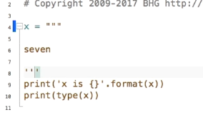**PONOVI**

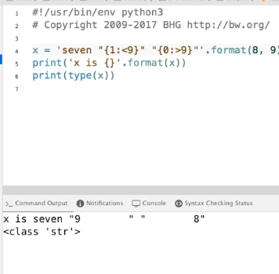

**indeks:uvjet**

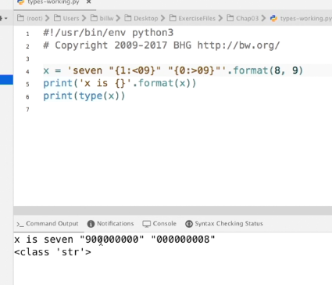

**PONOVI**

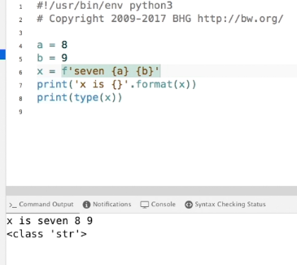

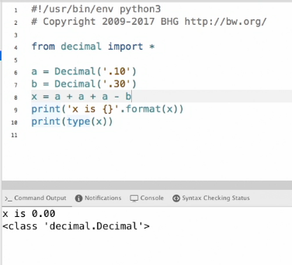

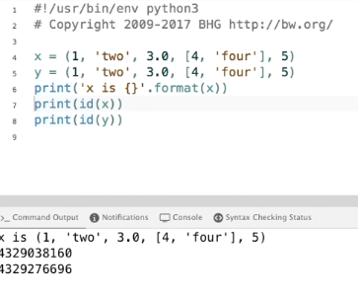

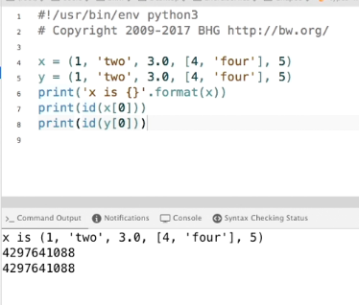 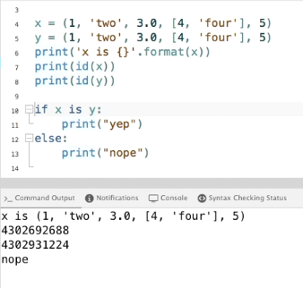 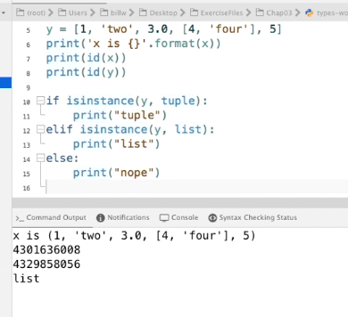 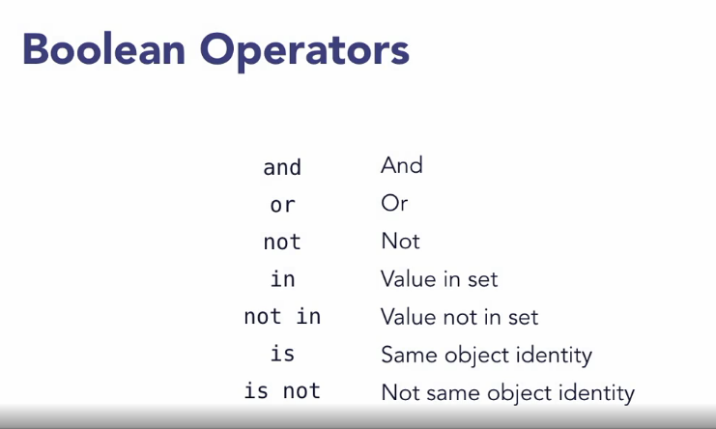

## 3.3.) Metode

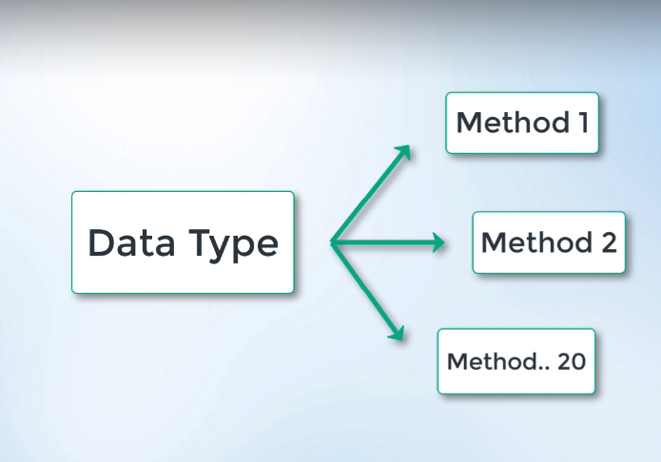

Svaki tip podatka ima svoje metode koje pozivam pomoću **.** operatora.

Npr. string ima neke poput: **find()**, **count()**, **split()**…

Primjer: **print(10*result.upper())**

Primjer: **print(10*result.count('\''))**

## 3.4.) Liste

Razlika između stringova i lista je u tome što elementima liste možemo pristupati i mijenjati ih.

Liste su mutabale.

Stringove ne možemo mijenjati na taj način, stringovi su unmutalbe.

I Stringovi i Liste su „oredered“ zato jer su određeni indexnim rednim brojevima.

### 3.4.1) Sequence

**[prvi, drugi, treći],** sa pripadajućim indexima. Mogu sadržavati različite tipove podaaka.

Stringovima isto mogu pristupati preko indexa!

**print(result[5])**

### 3**.4.2.) Slicing**

**print(lista[0:4]) –** umjesto početnog i krajnjeg maksimalnog broja, možemo ne napisati ništa. To podrazumijeva sami početak ili sami kraj.

**range(0,4)** – možemo koristiti i ovu funkciju za kreiranje liste, treći argument je argument koraka

**print(list(range(0, 100, 5)))**

## 3.5.) Membership operators

**in**, **not in**

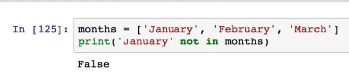

Provjerava sadržaj neke varijable i vraća True ili False.

## 3.6.) Often Used Functions in Python

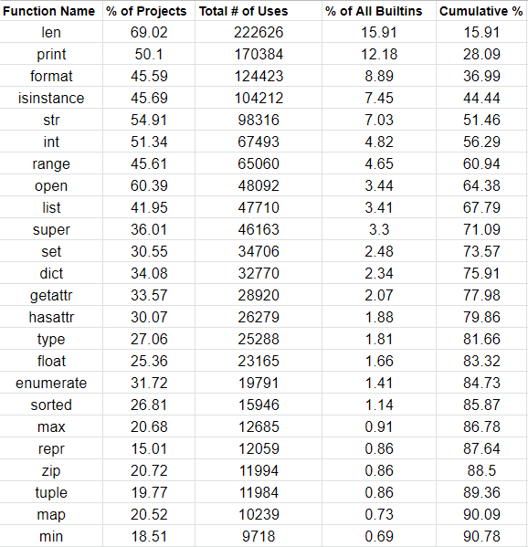

Neke funkcije, npr. **max()**, različito funkcioiraju za različit tip podataka.

Ako tražim **max()** iz liste stringova, dobit ću najduži string. Ako tražim max() iz liste integera, dobit ću najveći broj.

Ako tražim **max()** iz liste kombiniranih tipova podataka, dobit ću grešku.

**'-'.join(['1', '2', '3'])**

**sorted() –** abecedno sortira stringove

**print("Nabijem te na {}".format("kurac")) –** funkcija format unutar zagrada ubacuje neku zadanu vrijednost

**.append(„vrijednost“)** – proširujemo listu nekom novom informacijom

## 3.7.) Tuples

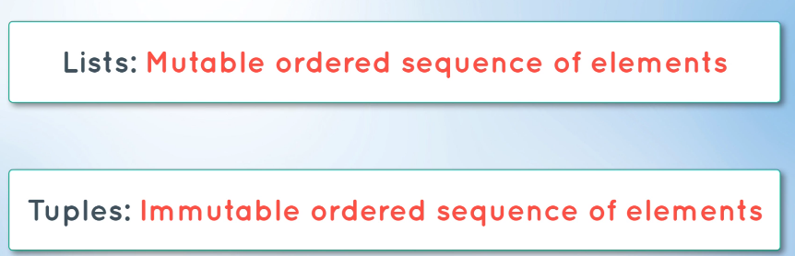

list = [a,b,c]

tuple={a,b,c}

Tuple koristimo kada spremamo neke vrlo povezane podatke.

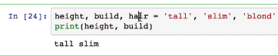Tuples možemo koristiti i bez zagrada. Ovo lijevo zovemo „tuple upacking“.

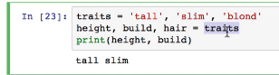

## 3.8.) Sets

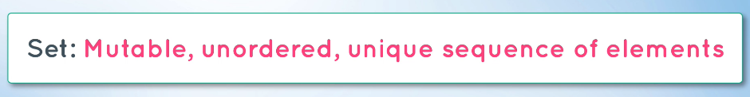

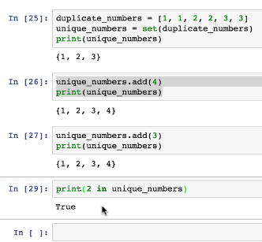**set()** funkcija uklanja višestruke članove.

**add()** funkcija dodaje član samo ako on već nije sadržan u skupu podataka.

## 3.9.) Dictinaoris

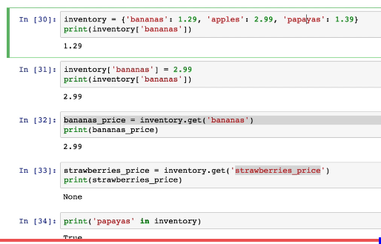

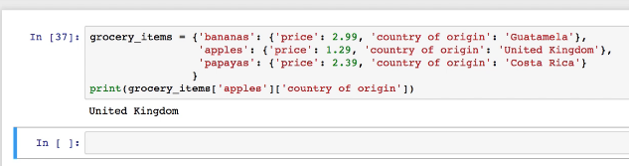

## 3.10.) Kombinacija

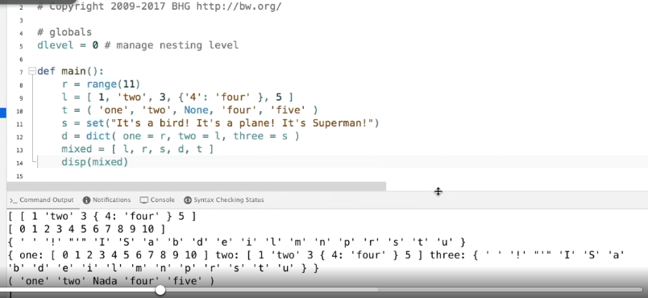

## 3.11.) Sintaksa izjava i petlji

### 3.11.1.) if-else

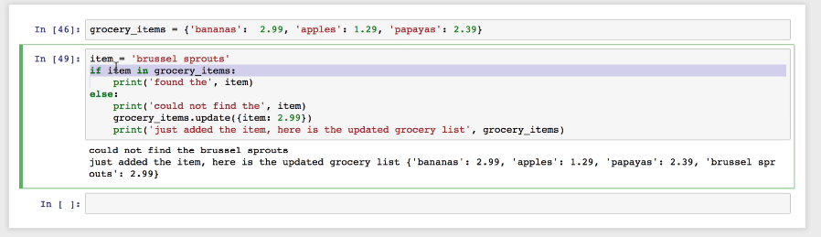

### 3.11.2.) elif

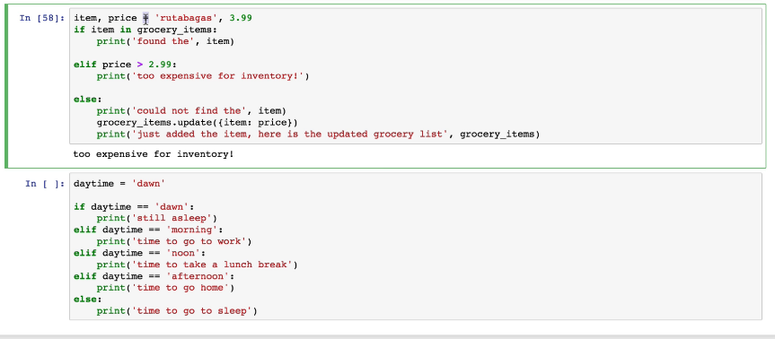

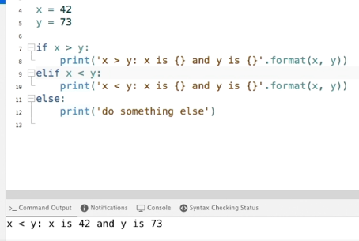

### 3.11.3.) for

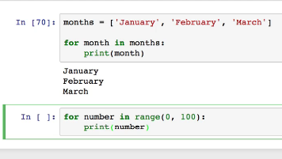

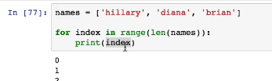

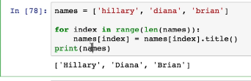

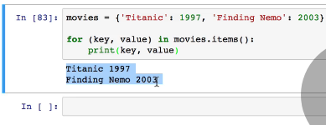For petlja kod

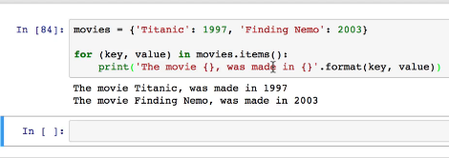

### 3.11.4.) While

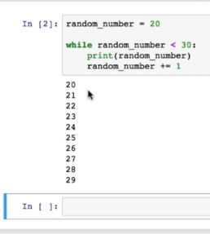

Pripazi na **break** i **continue** ključne riječi u petljama.

## 3.12.) Funkcije

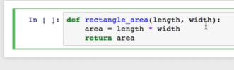

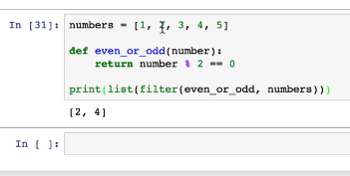

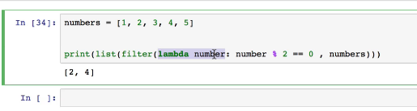

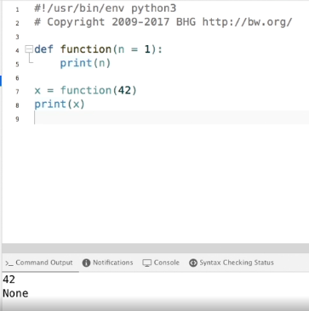

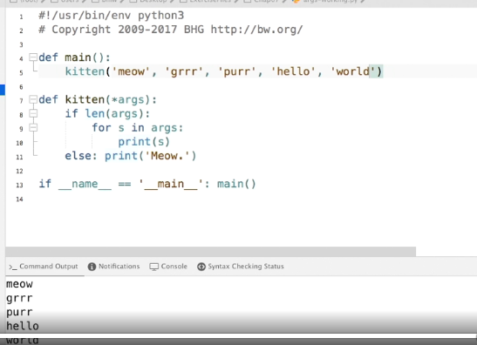 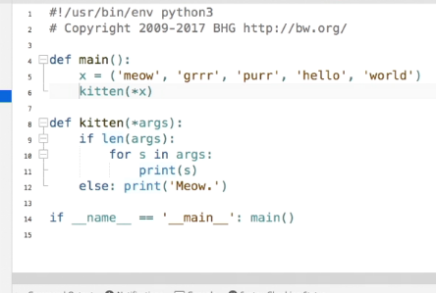 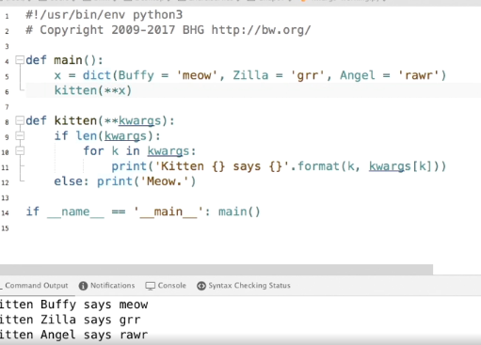Keyword argument – standard u pisanju pythona

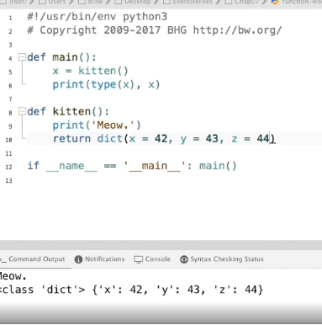

Distionary kao povratna vrijednost funkcije

**\*Generators**

**\*Decorators**

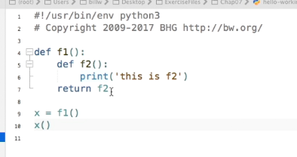 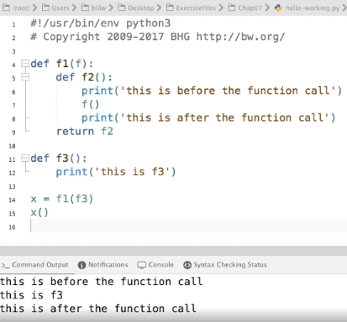 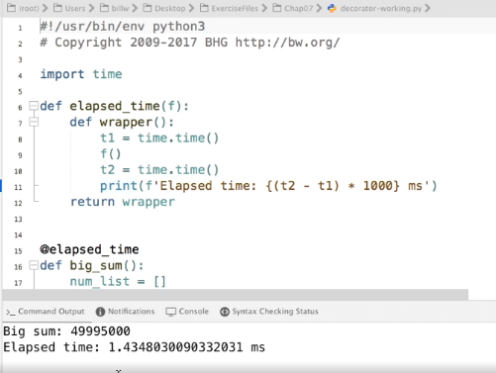

## 3.13.) Klase

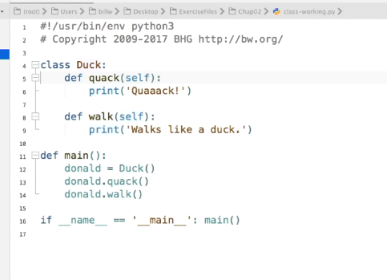

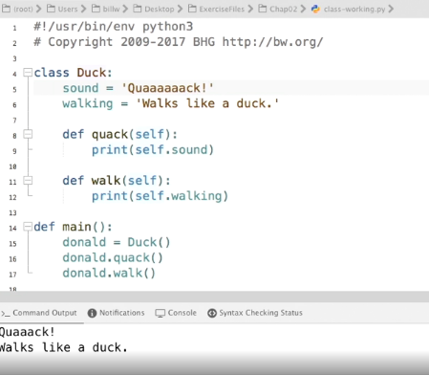

Ponovi klase bolje!

# 4) NumPy Crash Course – 1h 6 min

## 4.1.) NumPy

NumPy je biblioteka sa raznim matematičkim funkcijama.

NumPy is a library for the [Python programming language](https://en.wikipedia.org/wiki/Python_(programming_language)), adding support for large, multi-dimensional [arrays](https://en.wikipedia.org/wiki/Array_data_structure) and [matrices](https://en.wikipedia.org/wiki/Matrix_(math)), along with a large collection of [high-level](https://en.wikipedia.org/wiki/High-level_programming_language) [mathematical](https://en.wikipedia.org/wiki/Mathematics) [functions](https://en.wikipedia.org/wiki/Function_(mathematics)) to operate on these arrays.

Using NumPy in Python gives functionality comparable to [MATLAB](https://en.wikipedia.org/wiki/MATLAB) since they are both interpreted,[[17]](https://en.wikipedia.org/wiki/NumPy#cite_note-17) and they both allow the user to write fast programs as long as most operations work on arrays or matrices instead of [scalars](https://en.wikipedia.org/wiki/Scalar_(computing)).

## 4.2.) Arrays vs. Lists

Arrays(array – red) su vrlo slične listama, međutim, u liste možemo spremati podatke raznog tipa dok Arrays koristimo kao vektore. Jednodimenzionalne ili višedimenzionalne.

Razlog zašto koristimo Arrays se najbolje vidi na sljedećoj slici, u kodu gdje se obavlja operacija zbrajanja i potencijaranja dviju lista i dviju Arraya.

**np.arange(1, 4)** – kreira Array u nekom zadanom intervalu

**np.power(array, potencija)** – potencira neki array

**np.negative(array)** – vraća negativne vrijednosti

**np.exp(array)** – primijenjuje eksponencijalnu funkciju na svakog od člana

**np.log(array)** – primjenjuje logaritamsku funkciju na svakog člana

**np.sin(array)** – primjenjuje sinusnu funkciju na svakog člana

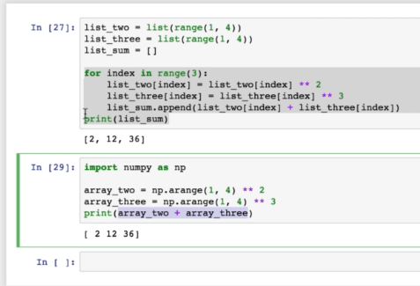

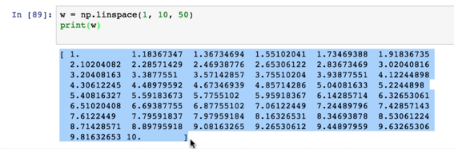

**np.linespace(a, b, c, Bool)** – neki raspon brojeva dijeli na određen broj vrijednosti. Ovo ne treba miješati sa step argumentom koji se kao treći po redu stavlja u range() funkciju.

Boolean argument određuje da li uključujemo posljednji broj, broj 10.0 ili ne.

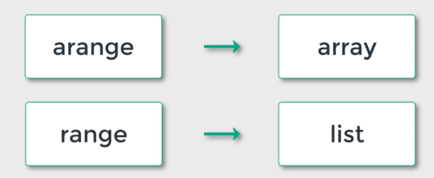

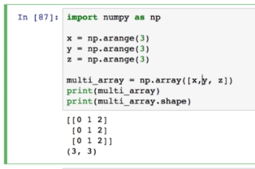Višedimenzionalni array.

**ime_array.np.int(16)** – modificira raspon dostupnih integera

## 4.3.) Slicing 1

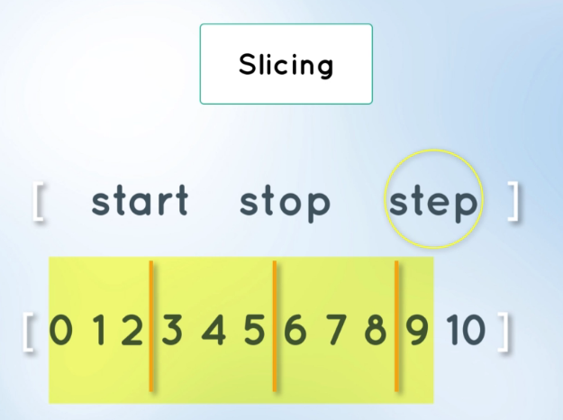

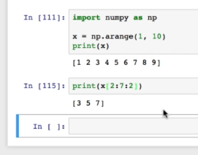

## 4.4.) Reshaping

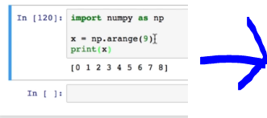 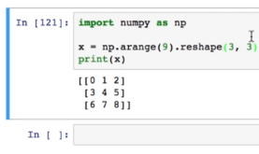

**reshape(a,b)** – koristimo kako bi preoblikovali array iz npr. 1D u 3D

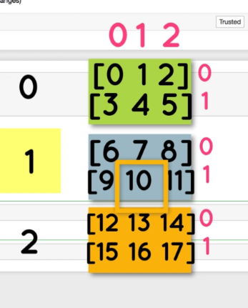 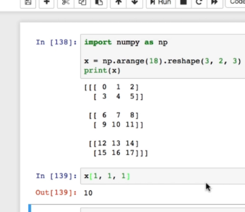

## 4.5.) Slicing 2

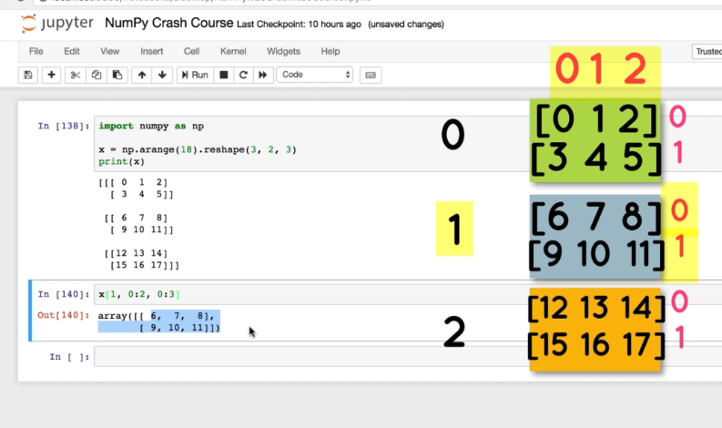

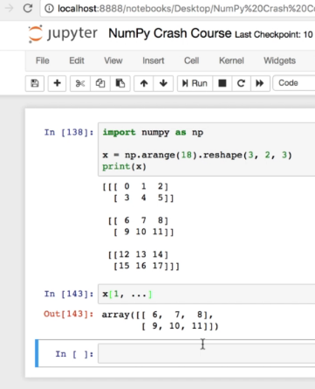 Tri točke u ovom slučaju mijenjaju oznake : i :

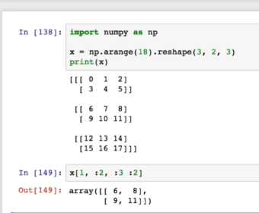 Možemo birati i step size kod slicinga podataka.

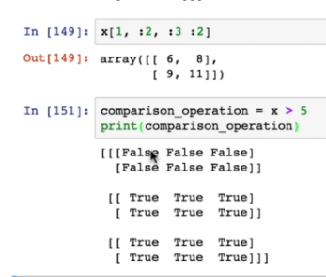Također možemo provjeriti neke logičke uvjete cijelog arraya.

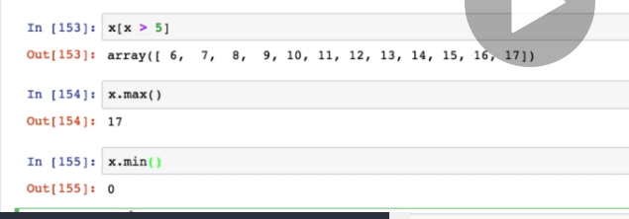

Možemo ispisivati specifične vrijednosti.

**min()** – minimalna

**max()** - maksimalna

**flatten(), ravel()** – pretvaraju array u 1D. Razlika između njih je u tome što flatten ne utječe na originalni array a ravel utječe.

**transpose()**, ili **.T** transponiraju array

**resize(array, (n, m))** – povećava dimenzije arraya i nova mjesta ispunjava postojećim podacima

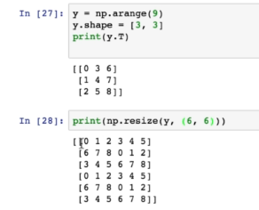

**zeros()** – ispunjava array nulama

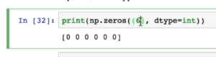

**eye()** – jedinična matrica

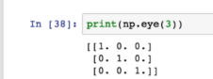

**random()** – nasumične vrijednosti od 0 do 1

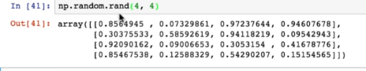

**hstack()** – horizontalno spajamo arraye

**vstack()** – vertikalno spajamo arraye

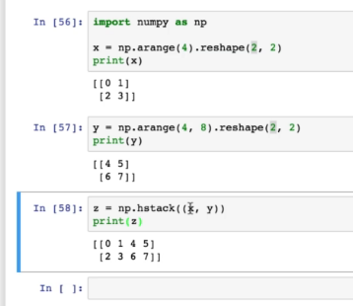

**concatenate(arr1, arr2, axis = 0/1)** – isto kao i prethodne dvije

**dstack()** – dodaje više dimenzija u dubinu

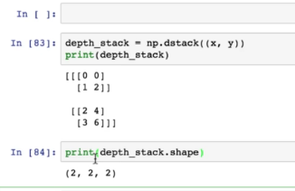

**column_stack()** , **row_stack() –** spaja stupce ili retke

# 5) Computer Vision: Finding Lane Lines – 1h 23 min

U ovom poglavlju zadatak je napisati kod koji će prepoznati linijska obilježja na cesti, tj. na slici ceste. Nakon toga kod modificirati tako da se ta obilježja prepoznaju u video zapisu. Video zapisu koji predstavlja putovanje cestom. Koristi se [**OpenCV**](https://en.wikipedia.org/wiki/OpenCV) biblioteka koja sadrži alate za obradu slike.

Na ovaj način vršimo početnu pripremu naših podataka koje poslije proslijeđujemo neuronskoj mreži.

**_____________________________________________________________________________________**

## 5.1.) OpenCV

**OpenCV** (*Open source computer vision*) is a [library of programming functions](https://en.wikipedia.org/wiki/Library_(computing)) mainly aimed at real-time [computer vision](https://en.wikipedia.org/wiki/Computer_vision).[[1]](https://en.wikipedia.org/wiki/OpenCV#cite_note-1) Originally developed by [Intel](https://en.wikipedia.org/wiki/Intel_Corporation). OpenCV supports some models from [deep learning](https://en.wikipedia.org/wiki/Deep_learning) frameworks like[**TensorFlow**](https://en.wikipedia.org/wiki/TensorFlow)**,**[**Torch**](https://en.wikipedia.org/wiki/Torch_(machine_learning))**,**[**PyTorch**](https://en.wikipedia.org/wiki/PyTorch) (after converting to an ONNX model) and [**Caffe**](https://en.wikipedia.org/wiki/Caffe_(software))according to a defined list of supported layers.[[3]](https://en.wikipedia.org/wiki/OpenCV#cite_note-3). It promotes OpenVisionCapsules. [[4]](https://en.wikipedia.org/wiki/OpenCV#cite_note-4), which is a portable format, compatible with all other formats.

* OpenCV is written in [C++](https://en.wikipedia.org/wiki/C%2B%2B) and its primary interface is in C++, but it still retains a less comprehensive though extensive older [C interface](https://en.wikipedia.org/wiki/C_(programming_language)). There are bindings in [Python](https://en.wikipedia.org/wiki/Python_(programming_language)), [Java](https://en.wikipedia.org/wiki/Java_(programming_language)) and [MATLAB](https://en.wikipedia.org/wiki/MATLAB)/[OCTAVE](https://en.wikipedia.org/wiki/GNU_Octave). The API for these interfaces can be found in the online documentation.[[13]](https://en.wikipedia.org/wiki/OpenCV#cite_note-Cdocs-13) Wrappers in other languages such as [C#](https://en.wikipedia.org/wiki/C_Sharp_(programming_language)), [Perl](https://en.wikipedia.org/wiki/Perl),[[14]](https://en.wikipedia.org/wiki/OpenCV#cite_note-14) [Ch](https://en.wikipedia.org/wiki/Ch_(computer_programming)),[[15]](https://en.wikipedia.org/wiki/OpenCV#cite_note-15) [Haskell](https://en.wikipedia.org/wiki/Haskell_(programming_language)),[[16]](https://en.wikipedia.org/wiki/OpenCV#cite_note-16) and [Ruby](https://en.wikipedia.org/wiki/Ruby_(programming_language)) have been developed to encourage adoption by a wider audience.
* Since version 3.4, **OpenCV.js** is a [JavaScript](https://en.wikipedia.org/wiki/JavaScript) binding for selected subset of OpenCV functions for the web platform. [[17]](https://en.wikipedia.org/wiki/OpenCV#cite_note-17)
* All of the new developments and algorithms in OpenCV are now developed in the C++ interface.

OpenCV's application areas include:

* 2D and 3D feature toolkits
* [Egomotion](https://en.wikipedia.org/wiki/Egomotion) estimation
* [Facial recognition system](https://en.wikipedia.org/wiki/Facial_recognition_system)
* [Gesture recognition](https://en.wikipedia.org/wiki/Gesture_recognition)
* [Human–computer interaction](https://en.wikipedia.org/wiki/Human%E2%80%93computer_interaction) (HCI)
* [Mobile robotics](https://en.wikipedia.org/wiki/Mobile_robotics)
* Motion understanding
* Object identification
* [Segmentation](https://en.wikipedia.org/wiki/Segmentation_(image_processing)) and recognition
* [Stereopsis](https://en.wikipedia.org/wiki/Stereopsis) stereo vision: depth perception from 2 cameras
* [Structure from motion](https://en.wikipedia.org/wiki/Structure_from_motion) (SFM)
* [Motion tracking](https://en.wikipedia.org/wiki/Video_tracking)
* [Augmented reality](https://en.wikipedia.org/wiki/Augmented_reality)

To support some of the above areas, OpenCV includes a statistical [machine learning](https://en.wikipedia.org/wiki/Machine_learning) library that contains:

* [Boosting](https://en.wikipedia.org/wiki/Boosting_(meta-algorithm))
* [Decision tree learning](https://en.wikipedia.org/wiki/Decision_tree_learning)
* [Gradient boosting](https://en.wikipedia.org/wiki/Gradient_boosting) trees
* [Expectation-maximization algorithm](https://en.wikipedia.org/wiki/Expectation-maximization_algorithm)
* [k-nearest neighbor algorithm](https://en.wikipedia.org/wiki/K-nearest_neighbor_algorithm)
* [Naive Bayes classifier](https://en.wikipedia.org/wiki/Naive_Bayes_classifier)
* [Artificial neural networks](https://en.wikipedia.org/wiki/Artificial_neural_network)
* [Random forest](https://en.wikipedia.org/wiki/Random_forest)
* [Support vector machine](https://en.wikipedia.org/wiki/Support_vector_machine) (SVM)
* [Deep neural networks](https://en.wikipedia.org/wiki/Deep_neural_network) (DNN)[[12]](https://en.wikipedia.org/wiki/OpenCV#cite_note-DNN-12)

**_____________________________________________________________________________________**

## 5.2.) TensorFlow

**TensorFlow** is a [free](https://en.wikipedia.org/wiki/Free_software) and [open-source](https://en.wikipedia.org/wiki/Open-source_software) [software library](https://en.wikipedia.org/wiki/Library_(computing)) for [dataflow](https://en.wikipedia.org/wiki/Dataflow_programming) and [differentiable](https://en.wikipedia.org/wiki/Differentiable_programming) programming across a range of tasks. It is a symbolic math library, and is also used for [machine learning](https://en.wikipedia.org/wiki/Machine_learning) applications such as [neural networks](https://en.wikipedia.org/wiki/Neural_networks).[[4]](https://en.wikipedia.org/wiki/TensorFlow#cite_note-YoutubeClip-4) It is used for both research and production at [Google](https://en.wikipedia.org/wiki/Google)

<https://www.youtube.com/watch?v=UbMDK4UNtPA>

<https://www.youtube.com/watch?v=f5liqUk0ZTw>

## 5**.3.) PyTorch**

**PyTorch** is an [open source](https://en.wikipedia.org/wiki/Open_source) [machine learning](https://en.wikipedia.org/wiki/Machine_learning) [library](https://en.wikipedia.org/wiki/Library_(computing)) based on the [Torch](https://en.wikipedia.org/wiki/Torch_(machine_learning)) library,[[1]](https://en.wikipedia.org/wiki/PyTorch#cite_note-1)[[2]](https://en.wikipedia.org/wiki/PyTorch#cite_note-2)[[3]](https://en.wikipedia.org/wiki/PyTorch#cite_note-3) used for applications such as [computer vision](https://en.wikipedia.org/wiki/Computer_vision) and [natural language processing](https://en.wikipedia.org/wiki/Natural_language_processing).[[4]](https://en.wikipedia.org/wiki/PyTorch#cite_note-4)

PyTorch defines a class called Tensor (torch.Tensor) to store and operate on homogeneous multidimensional rectangular arrays of numbers. PyTorch Tensors are similar to [NumPy](https://en.wikipedia.org/wiki/NumPy) Arrays, but can also be operated on a [CUDA](https://en.wikipedia.org/wiki/CUDA)-capable [Nvidia](https://en.wikipedia.org/wiki/Nvidia) GPU. PyTorch supports various sub-types of Tensors.[[15](https://en.wikipedia.org/wiki/PyTorch#cite_note-15)

## 5.4.) Matplotlib

**Matplotlib** is a [plotting](https://en.wikipedia.org/wiki/Plotter) [library](https://en.wikipedia.org/wiki/Library_(computer_science)) for the [Python](https://en.wikipedia.org/wiki/Python_(programming_language)) programming language and its numerical mathematics extension [NumPy](https://en.wikipedia.org/wiki/NumPy). It provides an [object-oriented](https://en.wikipedia.org/wiki/Object-oriented_programming) [API](https://en.wikipedia.org/wiki/API) for embedding plots into applications using general-purpose [GUI toolkits](https://en.wikipedia.org/wiki/GUI_toolkit) like [Tkinter](https://en.wikipedia.org/wiki/Tkinter), [wxPython](https://en.wikipedia.org/wiki/WxPython), [Qt](https://en.wikipedia.org/wiki/Qt_(software)), or [GTK+](https://en.wikipedia.org/wiki/GTK%2B). There is also a [procedural](https://en.wikipedia.org/wiki/Procedural_programming) "pylab" interface based on a [state machine](https://en.wikipedia.org/wiki/State_machine) (like [OpenGL](https://en.wikipedia.org/wiki/OpenGL)), designed to closely resemble that of [MATLAB](https://en.wikipedia.org/wiki/MATLAB), though its use is discouraged.[[3]](https://en.wikipedia.org/wiki/Matplotlib#cite_note-3) [SciPy](https://en.wikipedia.org/wiki/SciPy) makes use of **Matplotlib**

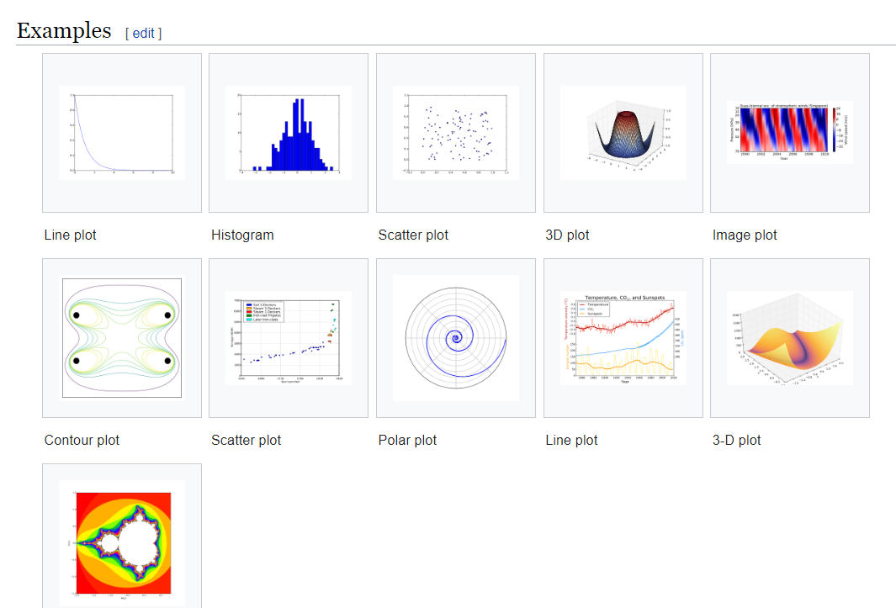

**_____________________________________________________________________________________**

Napomena: Direktorij mijenjam naredbom, npr.: **cd Desktop**

## 5.5.) Primjer sa praćenjem linija

### 5.5.1.) Prvi korak – Učitavanje Slike/Videa

Učitam sliku: image = cv2.imread('test_image.jpeg')

Syntax: cv2.imread(path, flag)

Parameters:  
path: A string representing the path of the image to be read.  
flag: It specifies the way in which image should be read. It’s default value is cv2.IMREAD_COLOR

cv2.IMREAD_COLOR: It specifies to load a color image. Any transparency of image will be neglected. It is the default flag. Alternatively, we can pass integer value 1 for this flag.  
cv2.IMREAD_GRAYSCALE: It specifies to load an image in grayscale mode. Alternatively, we can pass integer value 0 for this flag.  
cv2.IMREAD_UNCHANGED: It specifies to load an image as such including alpha channel. Alternatively, we can pass integer value -1 for this flag.

**Alpha Channel:** It’s for transparency. You could call it the “transparency map.”

Some people say it is “opacity” (the opposite of transparency), but since the default is generally for a pixel to be fully opaque (that is, an image without an alpha channel will simply treat all pixels as if they are 100% opaque), I say “transparency”, because I think that is more clear. Haha pun intended.

A pixel in a typical image has 3 values: red, green and blue. Usually they range from 0 to 255. So a pixel which has the values 255, 0, 0 is pure red — maximum value for the red component, minimum values for both green and blue.

With an image that has an alpha channel, each pixel has four components: red, green blue and alpha. Alpha of 255 is opaque, while alpha of 0 is transparent.

The term “alpha channel” refers to the alpha components of all pixels taken together as a whole. (you can also refer to the red channel, etc) As mentioned above, an alternate term that is more likely to be easily understood by laypeople is “transparency map.”

PNG format allows for alpha channel, while JPEG does not. GIF images can have transparency, but it is all or nothing, each pixel will be completely transparent (and therefore have no color), or completely opaque.

Typical use of alpha channel is to simply have an area of the image be “background”, and partially transparent pixels are either right on the edge of the foreground, or are part of a shadow that overlays the background. However there are all kinds of cool things you can do with alpha channel images. Here’s one thing I built that uses the alpha channel to represent the color of the main object, while the other channels are the shading and reflections. This allows you to realistically change the color of the object simply by altering whatever is behind the images, even allowing for black, white and gray.

[Color changer](https://pianop.ly/colorchange/)

(images below show the technique, as well as another alpha channel technique used to make “glowy text” out of my handwriting that can easily be dropped on top of another image)

### 5.5.2.) Kopiram sliku

lane_image = np.copy(image)

Originalnu sliku, tj. Array kopiram i dalje u kodu radim sa kopijom. Tako originalni Array držim netaknutim a mijenjam samo kopiju.

Zašto np.copy(), zašto ne lane_image=image?

Return an array copy of the given object.

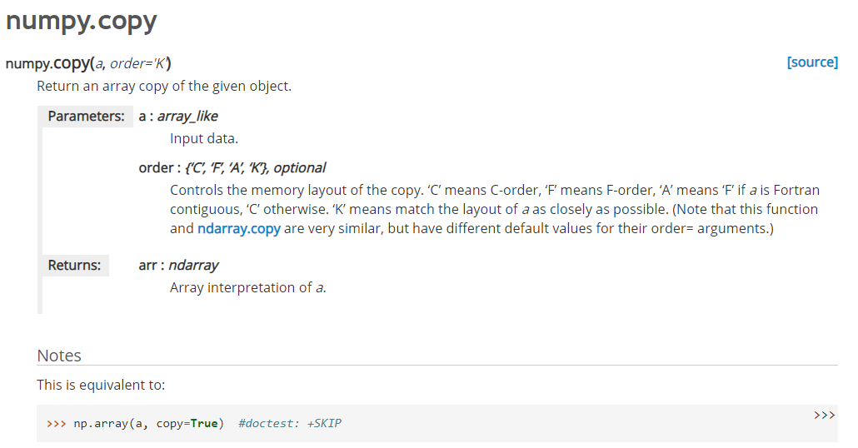

### 5.5.3.) Sivljenje

Prebacim je u sivo područje jer je s takvom slikom se lakše radi. Slika u boji ima tri kanala (RGB) dok slika u sivom području ima samo jedan kanal koji je određen vrijednostima od 0 do 255.

A što sa četvrtim kanalom – Opacity?

gray = cv2.cvtColor(image, cv2.COLOR_RGB2GRAY)

Zašto nisam koristio image = cv2.imread('test_image.jpeg', IMREAD_GRAYSCALE) i tako odmah pri učitavanju sliku prebacio u sivo područje?

Napomena: ovu funkciju naknadno prebacujem u Mycanny() funkciju koju sam definiram.

### 5.5.4.) Peglanje slike

Blur funkcijom, tj. Gaussovim filtriranjem, koristim [kernel](https://www.google.com/search?q=what+is+kernel&oq=what+is+kernel&aqs=chrome..69i57j0l7.1782j0j7&sourceid=chrome&ie=UTF-8) za peglanje slike, što omogućuje bolje prepoznavanje rubova slike. Prepoznavanje rubova će biti objašnjeno u sljedećem koraku.

As in any other signals, images also can contain different types of noise, especially because of the source (camera sensor). Image Smoothing techniques help in reducing the noise. In OpenCV, image smoothing (also called blurring) could be done in many ways. Mathematically, applying a Gaussian blur to an image is the same as [convolving](https://en.wikipedia.org/wiki/Convolution) the image with a [Gaussian function](https://en.wikipedia.org/wiki/Gaussian_function). This is also known as a two-dimensional [Weierstrass transform](https://en.wikipedia.org/wiki/Weierstrass_transform).

Image blurring is achieved by convolving the image with a low-pass filter kernel. It is useful for removing noise. It actually removes high frequency content (e.g: noise, edges) from the image resulting in edges being blurred when this is filter is applied. (Well, there are blurring techniques which do not blur edges). OpenCV provides mainly four types of blurring techniques.

As for one-dimensional signals, images also can be filtered with various low-pass filters (LPF), high-pass filters (HPF), etc. A LPF helps in removing noise, or blurring the image. A HPF filters helps in finding edges in an image.

OpenCV provides a function, **cv2.filter2D()**, to convolve a kernel with an image. As an example, we will try an averaging filter on an image. A 5x5 averaging filter kernel can be defined as follows:

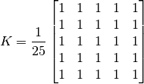

Filtering with the above kernel results in the following being performed: for each pixel, a 5x5 window is centered on this pixel, all pixels falling within this window are summed up, and the result is then divided by 25. This equates to computing the average of the pixel values inside that window. This operation is performed for all the pixels in the image to produce the output filtered image.

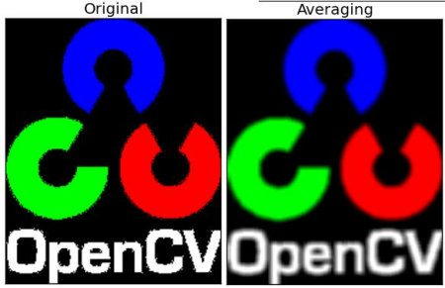

**1. Averaging**

This is done by convolving the image with a normalized box filter. It simply takes the average of all the pixels under kernel area and replaces the central element with this average. This is done by the function cv2.blur() or cv2.boxFilter(). Check the docs for more details about the kernel. We should specify the width and height of kernel. A 3x3 normalized box filter would look like this:

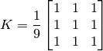

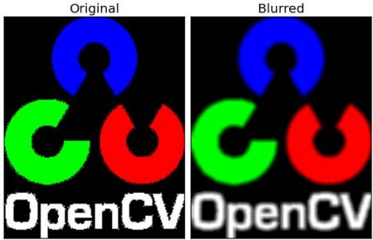

**2. Gaussian Filtering**

In this approach, instead of a box filter consisting of equal filter coefficients, a Gaussian kernel is used. It is done with the function, cv2.GaussianBlur(). We should specify the width and height of the kernel which should be positive and odd. We also should specify the standard deviation in the X and Y directions, sigmaX and sigmaY respectively. If only sigmaX is specified, sigmaY is taken as equal to sigmaX. If both are given as zeros, they are calculated from the kernel size. Gaussian filtering is highly effective in removing Gaussian noise from the image.

If you want, you can create a Gaussian kernel with the function, cv2.getGaussianKernel().

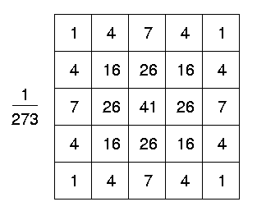

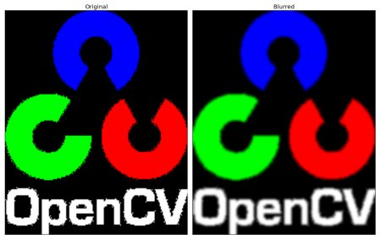

**3. Median Filtering**

Here, the function cv2.medianBlur() computes the median of all the pixels under the kernel window and the central pixel is replaced with this median value. This is highly effective in removing salt-and-pepper noise. One interesting thing to note is that, in the Gaussian and box filters, the filtered value for the central element can be a value which may not exist in the original image. However this is not the case in median filtering, since the central element is always replaced by some pixel value in the image. This reduces the noise effectively. The kernel size must be a positive odd integer.

In this demo, we add a 50% noise to our original image and use a median filter.

**4. Bilateral Filtering**

As we noted, the filters we presented earlier tend to blur edges. This is not the case for the bilateral filter, cv2.bilateralFilter(), which was defined for, and is highly effective at noise removal while preserving edges. But the operation is slower compared to other filters. We already saw that a Gaussian filter takes the a neighborhood around the pixel and finds its Gaussian weighted average. This Gaussian filter is a function of space alone, that is, nearby pixels are considered while filtering. It does not consider whether pixels have almost the same intensity value and does not consider whether the pixel lies on an edge or not. The resulting effect is that Gaussian filters tend to blur edges, which is undesirable.

The bilateral filter also uses a Gaussian filter in the space domain, but it also uses one more (multiplicative) Gaussian filter component which is a function of pixel intensity differences. The Gaussian function of space makes sure that only pixels are ‘spatial neighbors’ are considered for filtering, while the Gaussian component applied in the intensity domain (a Gaussian function of intensity differences) ensures that only those pixels with intensities similar to that of the central pixel (‘intensity neighbors’) are included to compute the blurred intensity value. As a result, this method preserves edges, since for pixels lying near edges, neighboring pixels placed on the other side of the edge, and therefore exhibiting large intensity variations when compared to the central pixel, will not be included for blurring.

The sample below demonstrates the use of bilateral filtering (For details on arguments, see the OpenCV docs).

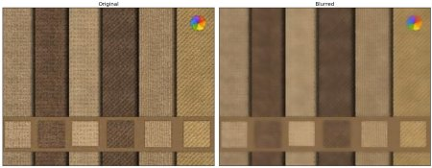

Za sada:

blur = cv2.GaussianBlur(gray, (5, 5), 0) #Prouči Gaussian Filtering. Peglamo sliku od šuma zbog bolje detekcije rubova.

<https://www.youtube.com/watch?v=C_zFhWdM4ic>

#(5, 5) - Kernel dimenzija 5x5 za peglanje slike. 0 -> Označava devijaciju

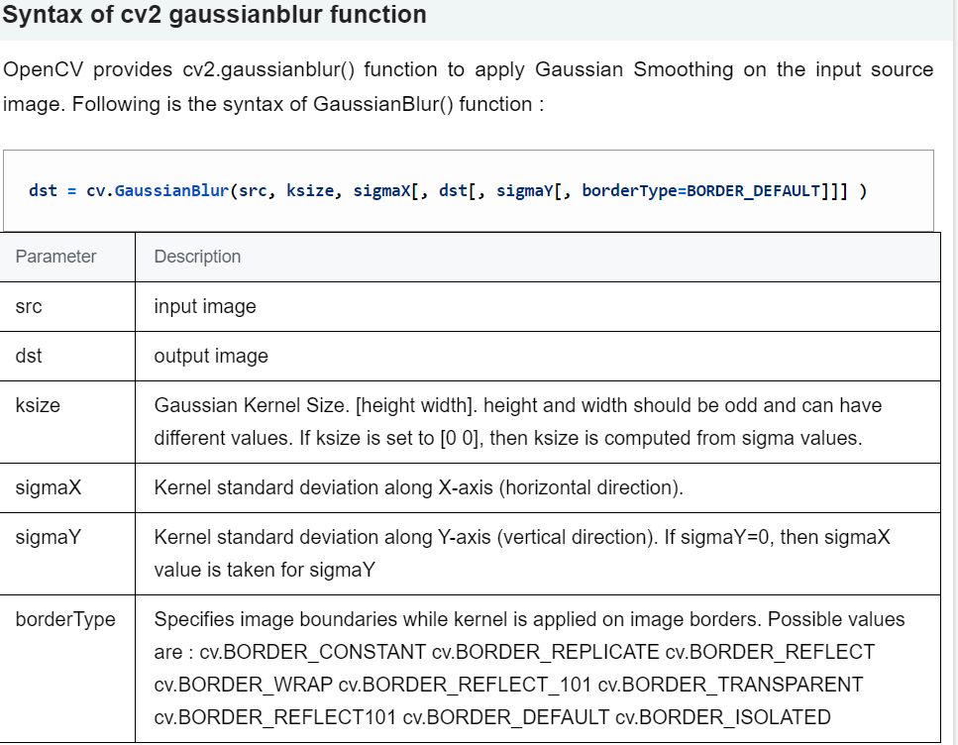

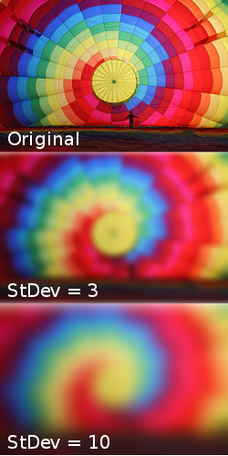

Ok, zbog čega ovo sve radim? – Šum na slici može uzrokovati pojavu “lažnih rubova” koji bi smetali u daljnjoj obradi slike.

Inače, ovaj korak je opcionalan zato jer canny() funkcija iz sljedećeg koraka također primjenjuje Gaussian Blur sa 5x5 kernelom.

Napomena: ovu funkciju naknadno prebacujem u Mycanny() funkciju koju sam definiram.

### 5.5.5.) Izdvajanje rubova

Rubove prepoznajemo uz pomoć računanja gradijenta po x i y varijabli slike.

[Gradijent](https://www.youtube.com/watch?v=GkB4vW16QHI&t=0s) dobivamo pomoću Canny funkcije.

Postoje i druge funkcije za izdvajanje rubova, na [Linku](https://docs.opencv.org/2.4/modules/imgproc/doc/feature_detection.html?highlight=canny).

Canny(image, edges, threshold1, threshold2)

- raspon između vrijednosti derivacija treba biti 1:2 ili 1:3., ne miješaj ovo sa MyCanny(image)

Npr. **Canny(image, 50, 150)**. Derivacije/diferencijali ispod 50 se odbacuju, derivacije iznad 150 se bilježe kao bijelo polje, derivacije koje između se prihvaćaju ili odbacuju ovisno o drugim uvjetima. Derivacija iznosa npr. 75 će biti prihvaćena ako je vezana uz neki rub, tj. u blizini vrijednosti veće od 150. A odbacit će se ako nije - ako sam dobro shvatio.

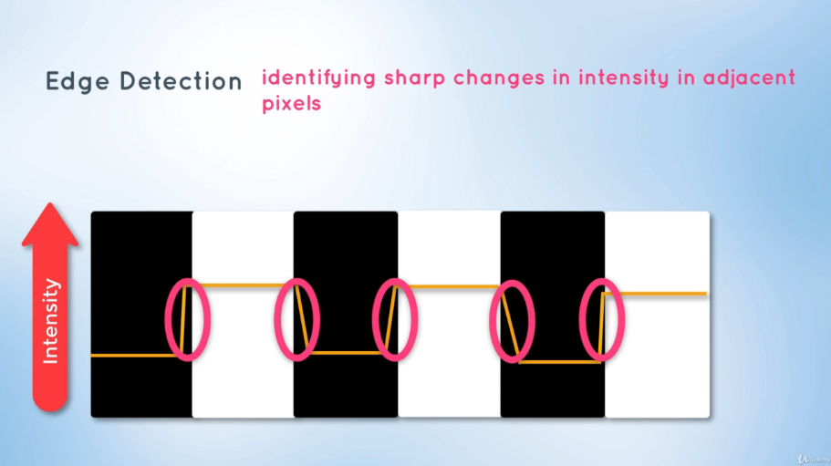

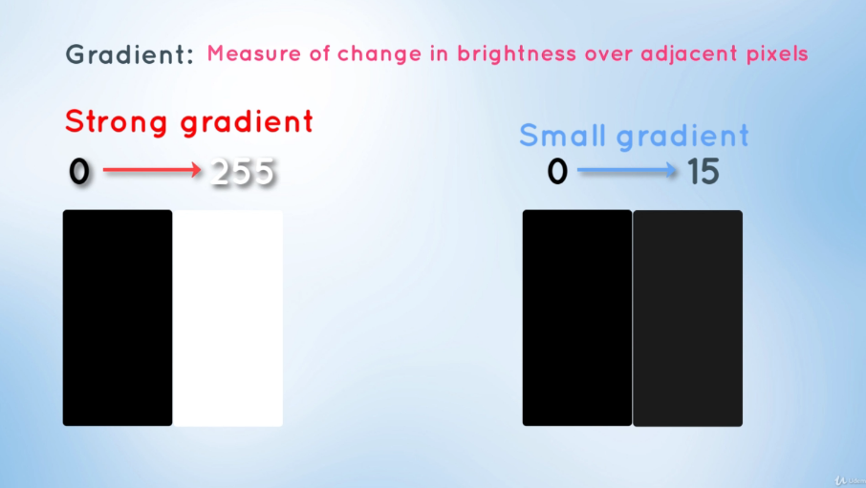

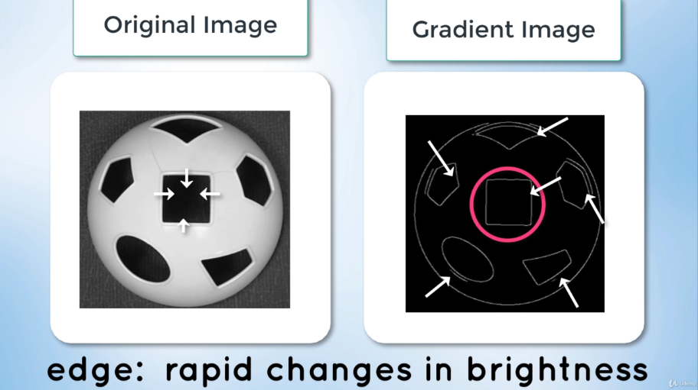

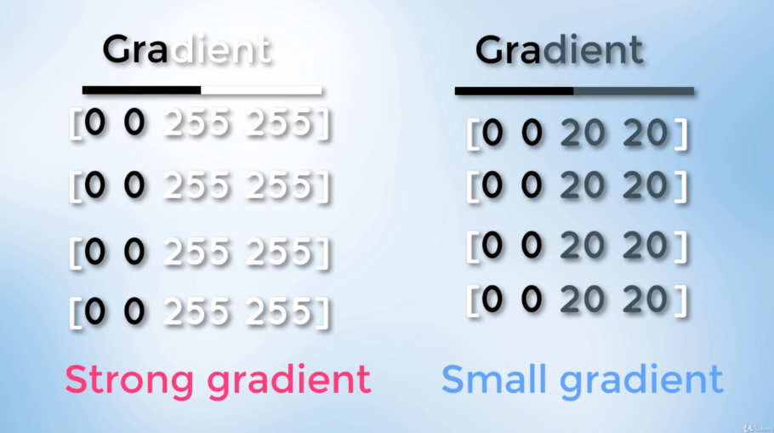

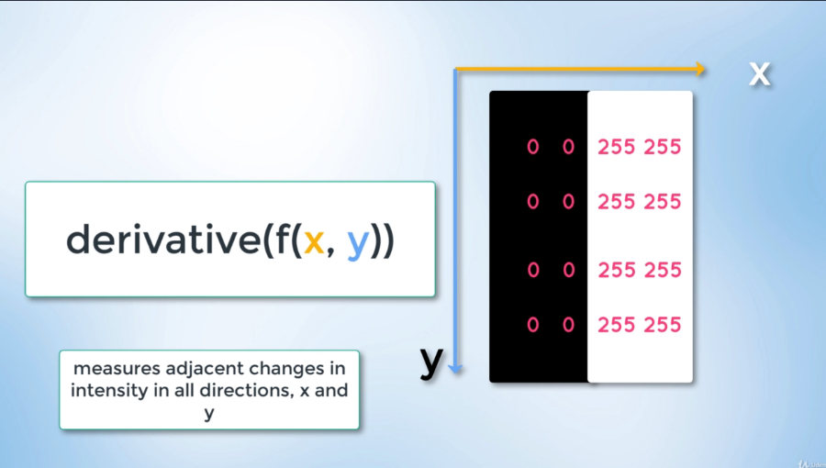

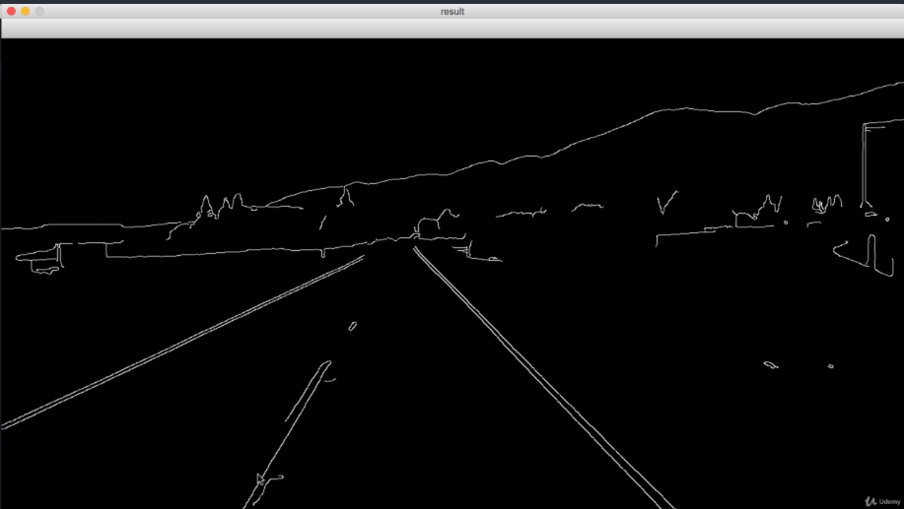

### 5.5.6) Odabir područja interesa

1. **MATPLOTLIB: import** [**matplotlib.pyplot**](https://matplotlib.org/3.2.1/api/_as_gen/matplotlib.pyplot.html) **as plt** - Pomoću ove biblioteke dodajem brojčane oznake na osi slike, koje mi trebaju kako bih odabrao interesno područje, a to je desna traka kolnika. Izabirem je kreiranjem trokuta sa koordinatnim točkama:

A(200, 700), B(1000, 700), C(600, 200)

[matplotlib.pyplot](https://matplotlib.org/3.2.1/api/_as_gen/matplotlib.pyplot.html#module-matplotlib.pyplot) is a state-based interface to matplotlib. It provides a MATLAB-like way of plotting. Ova bibilioteka je detaljnije objašnjena u poglavlju **5.4.)**_Matplotlib)

**plt.imshow(slika)** je ekvivalent za **cv2.imshow(“oznaka”, slika)** – Isto prikazuje sliku, ali je to funkcija iz druge biblioteke i ima određene razlike. Pomoću ovoga dobivamo sliku čije su osi brojčano označene, ovo je prvi korak kod odabira interesnog područja

**plt.show()** je ekvivalent za **cv2.WaitKey(0)**

[**Ovdje se nalaze objašnjenja za cv2.WaitKey(), cv2.imshow() i druge.**](https://docs.opencv.org/2.4/modules/highgui/doc/user_interface.html?highlight=waitkey)

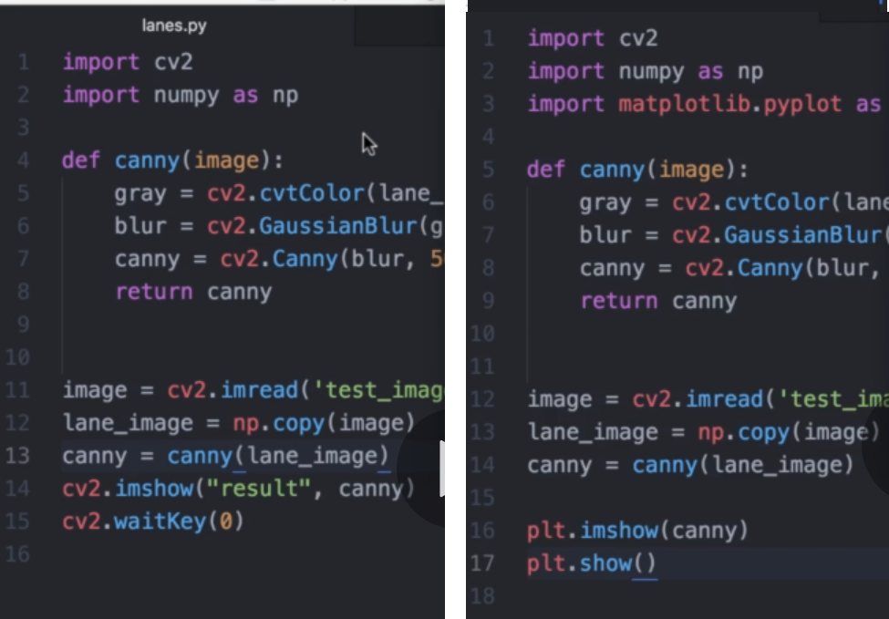

1. Kreiramo poligon, tj. bijeli trokut na crnoj podlozi, trokut predstavlja interesno područje. To činimo funkcijom **region_of_interest()** a **koju samo sami kreirali**. U toj funkciji koristimo **image.shape[0]**, **np.array()** (kreira poligon), **np.zeros_like()**, **cv2.fillPoly()**, **bitwise_and()**

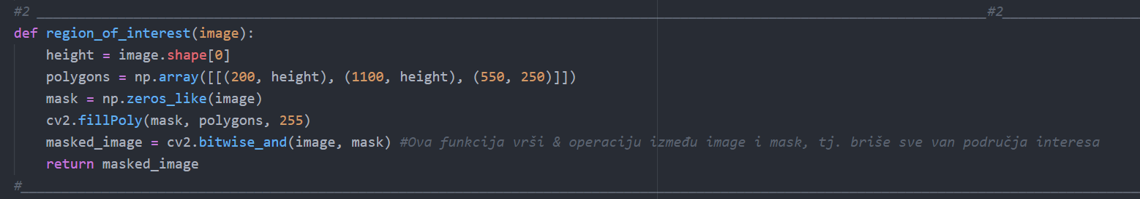

**image.shape[0]**: Image properties include number of rows, columns and channels, type of image data, number of pixels etc.

Shape of image is accessed by **img.shape()**. It returns a tuple of number of rows, columns and channels (if image is color):

>>> print img.shape

(342, 548, 3) – primjer.

If image is grayscale, tuple returned contains only number of rows and columns. So it is a good method to check if loaded image is grayscale or color image.

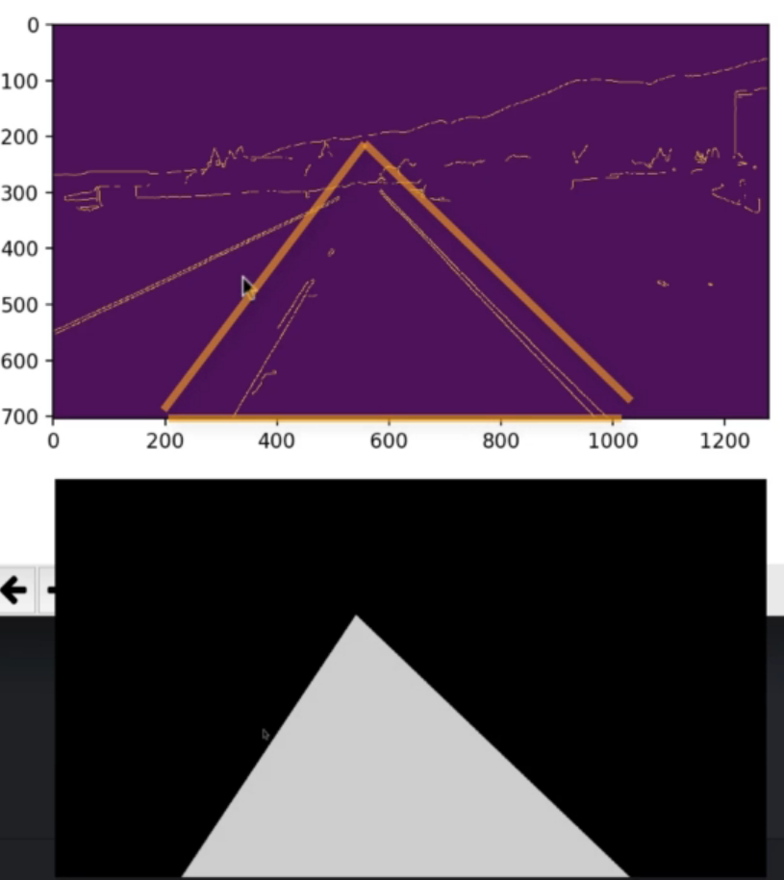

1. **np.array()** - kreira poligon

**polygons = np.array([[(200, height), (1100, height), (550, 250)]])**: Kreiram array koji predstavlja poligon, tj. trokut sa napisanim dimenzijama. Dvije uglate zagrade označava da se radi o dvodimenzionalnom liku. U ovom slučaju trokutu jer imamo tri para koordinata za tri točke.

Kako si arraye grafički predočiti?

1. **np.zeros_like()** - kreira array određenih dimenzija gdje su sve vrijednosti nula, tj. dobivamo crnu masku dimenzija naše slike

**mask = np.zeros_like(image) –** šaljem sliku image koja je zapravo array i ta slika/array se u funkciji zeros_like() transformira u nule. U biti, formiram crnu sliku koja ima dimenzije moje slike.

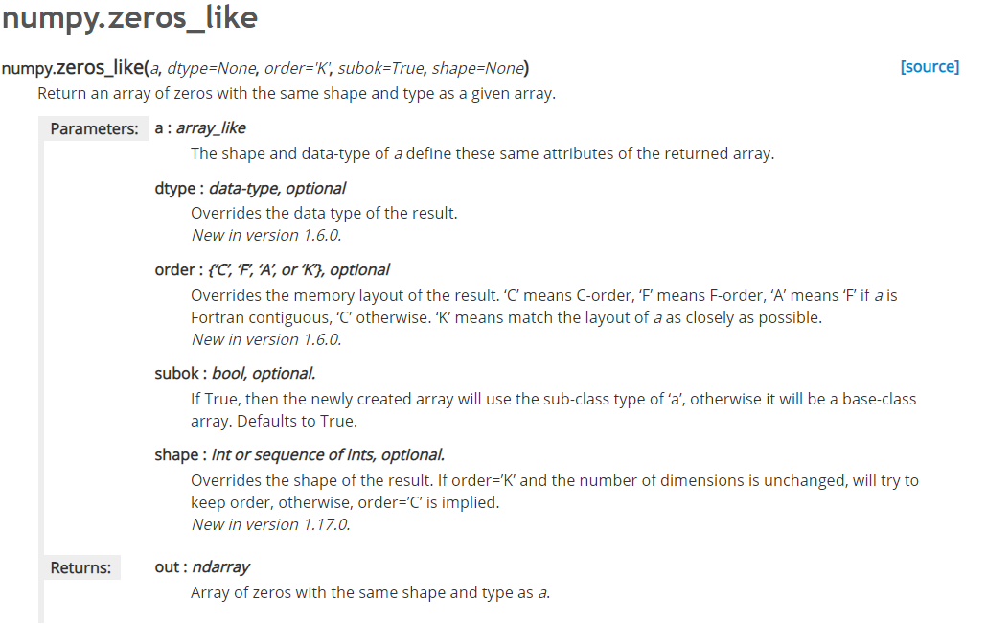

1. **cv2.fillPoly()** - na crnu sliku ubacujemo naš poligon (trokut) koji predstavlja područje interesa i ispunjavamo ga bijelom bojom.

**cv2.fillPoly(mask, polygons, 255)**

Bolje prouči ovu funkciju.

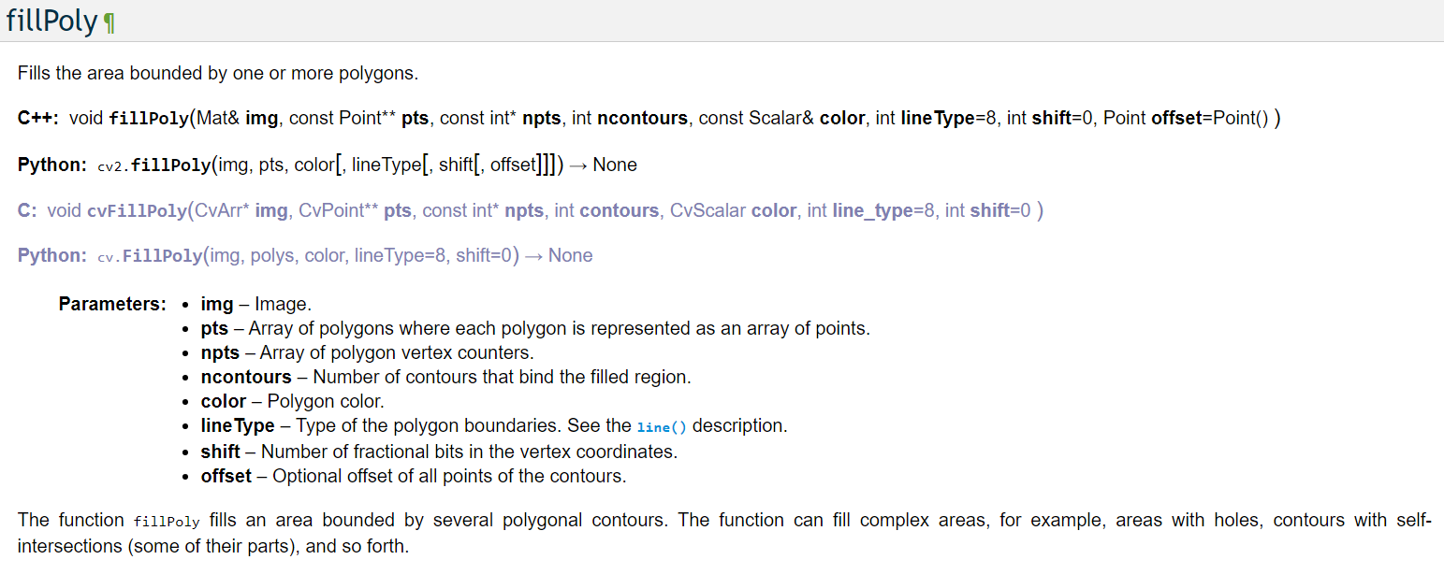

1. **bitwise_and(image, mask)** - Ova funkcija vrši & operaciju između image i mask, tj. briše sve van područja interesa

This includes the bitwise AND, OR, NOT, and XOR operations.

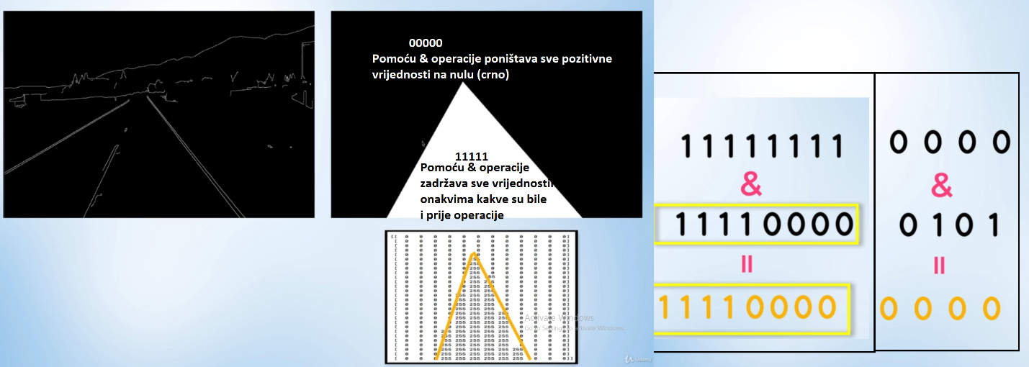

1. **cv2.imshow.HoughLines(cropped_image, 2, np.pi/180, 100, np.array([]), minLineLength=40, maxLineGap=5)**

Argument 1: Slika na kojoj želimo detektirati linije

Argument 2 i 3: (Pixel, radian) - Specificiraju rezoluciju **Houghove** "mreže" za omeđivanje točaka presjecišta. Što su vrijednosti veće, manja je preciznost detekcije.

Argument 4: Treshold - granična vrijednost broja presjecišta za koju uzimamo da se radi o pravcu. 100 je u ovom slučaju optimalna vrijednost, kaže lik.

Argument 5: "Place holder"

1. x1, y1, x2, y2 = line.reshape(4) - Pretvaramo sve u 1D array
2. cv2.line(line_image, (x1, y1), (x2, y2), (255, 0, 0), 10) ?????????????????????????????
3. Argument 6: Minimalna vrijednost duljine koju linija mora imati da bi ibila prihvaćena, u pikselima
4. Argument 7: Maksimalan procijep između linija kojega možemo samostalno popuniti i spojiti linije

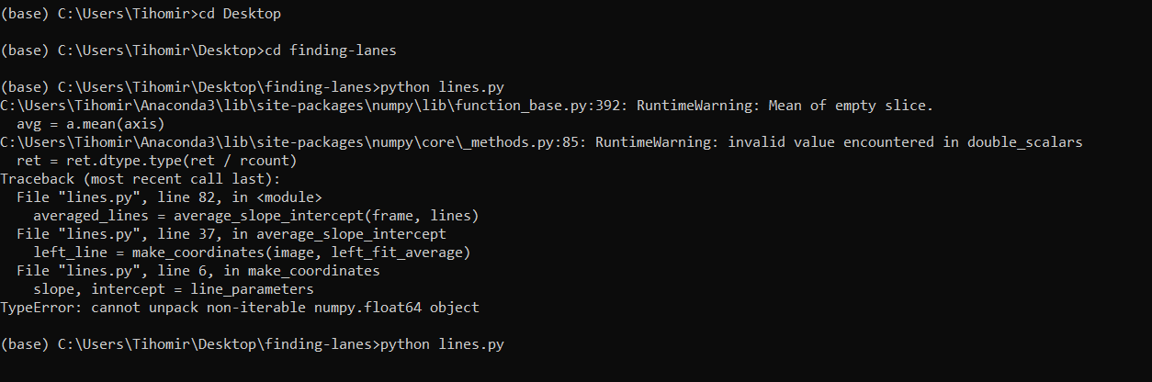

(base) C:\Users\Tihomir>cd Desktop

(base) C:\Users\Tihomir\Desktop>cd finding-lanes

(base) C:\Users\Tihomir\Desktop\finding-lanes>python lines.py

C:\Users\Tihomir\Anaconda3\lib\site-packages\numpy\lib\function_base.py:392: RuntimeWarning: Mean of empty slice.

avg = a.mean(axis)

C:\Users\Tihomir\Anaconda3\lib\site-packages\numpy\core\_methods.py:85: RuntimeWarning: invalid value encountered in double_scalars

ret = ret.dtype.type(ret / rcount)

Traceback (most recent call last):

File "lines.py", line 82, in <module>

averaged_lines = average_slope_intercept(frame, lines)

File "lines.py", line 37, in average_slope_intercept

left_line = make_coordinates(image, left_fit_average)

File "lines.py", line 6, in make_coordinates

slope, intercept = line_parameters

TypeError: cannot unpack non-iterable numpy.float64 object

[**Rješenje problema je ovdje.**](https://stackoverflow.com/questions/54273077/cannot-unpack-non-iterable-numpy-float64-object-python3-opencv)

[**I ovdje (Udemy).**](https://www.udemy.com/course/applied-deep-learningtm-the-complete-self-driving-car-course/learn/lecture/15942336#questions/5426152)

OPTIMIZACIJA SLIKE:

*averaged_lines = average_slope_intercept(line_image, lines) -> Svaka linija na pojedinoj strani ima različit intercept,

zato izgleda "iskidano". Taj intercept trebamo uprosječiti i dobiti jednu liniju. Pogledati

Houghov prostor

**_____________________________________________________________________________________**

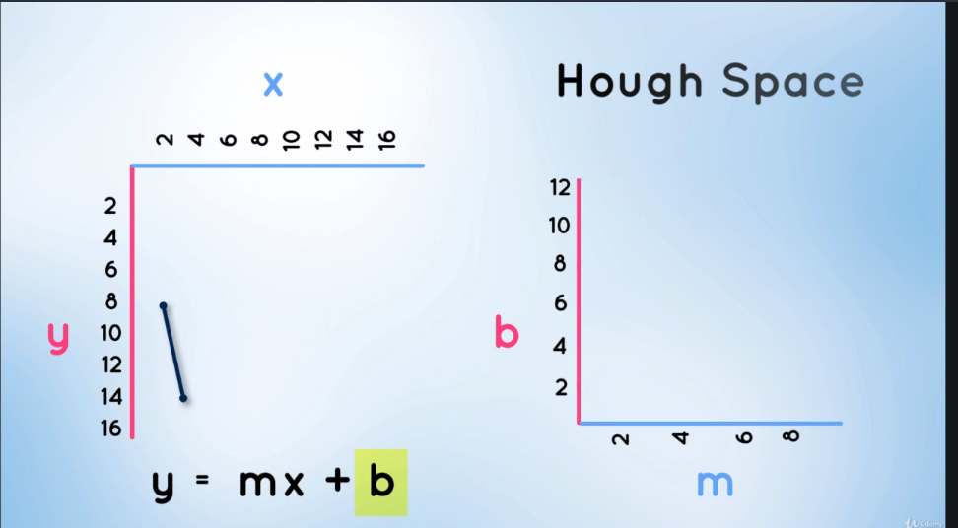

Na lijevoj strani se nalazi zapis jednadžbe pravca u x i y koordinatnom sustavu.

Na desnoj strani je zapis te varijable u parametarskom obliku, preko parametara m i b. Tj. koeficijenta pravca m i odsječka na x os b.

Takav parametarski zapis nazivamo Houghovim prostorom.

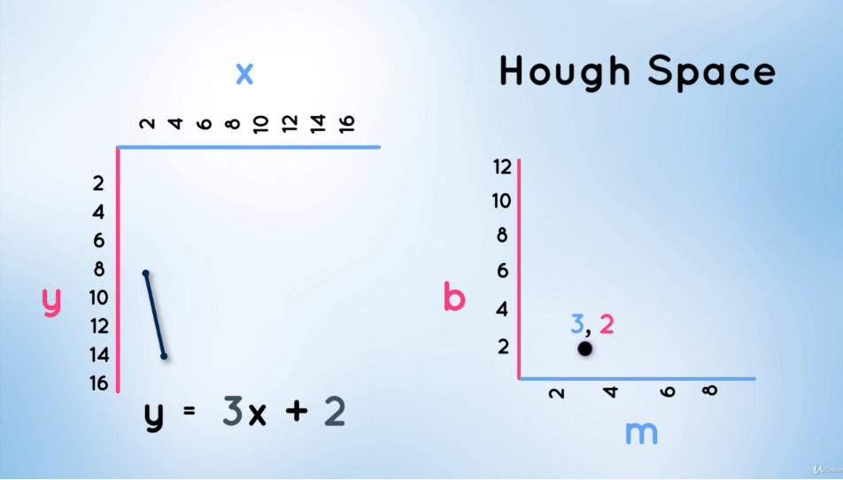

Ako imamo jednadžbu pravca y=3x+2, ona će u Houghovom prostoru biti predstavljena točkom sa koordinatama b=2 i m=3.

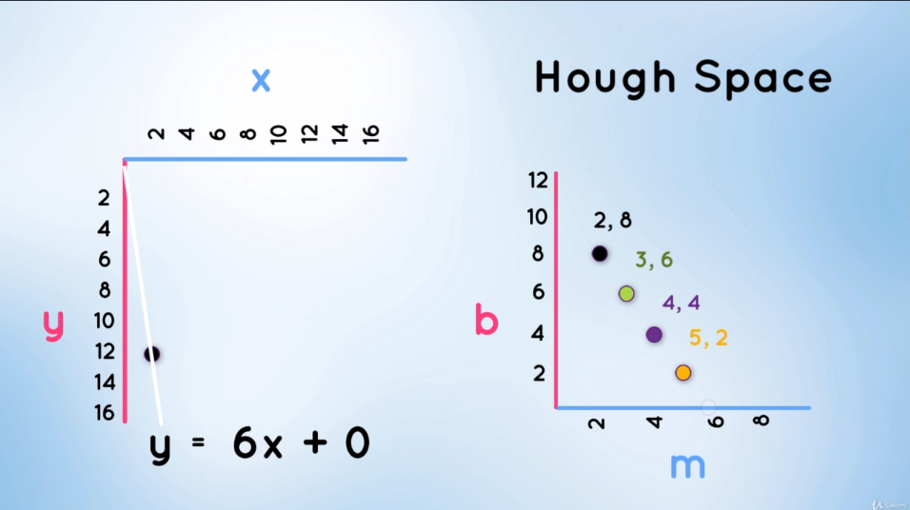

Ako u x,y koordinatmom sustavu imamo točku, kroz nju može prolaziti beskonačan broj pravaca tj. beskonačan broj kombinacija b i m vrijednosti. Napomena: To što možemo imati beskonačan broj kombinacija b i m vrijednosti ne znači da te vrijednosti mogu biti bilo koje. One moraju biti takve da pravac prolazi kroz zadanu zajedničku točku T(2, 12). Odnosno, moraju odgovarati jedndžbi: **2m+b-12=0**

Dakle, svaki pravac koji prolazi kroz točku T(2, 12) mora zadovoljavati prethodnu jednadžbu**. A što ako pravac prolazi kroz točku T(1, 6)? U tom slučaju točke moraju zadovoljavati jednadžbu m+b-6=0, tj. m+b=6.**

**2m+b=12**

**m+b=6**

**m+0b=6 => m=6**

**0m-b=0 => b=0**

**Zajednička točka, tj. zajedničko rješenje ova dva pravca u Houghovom prostoru je T(6,0). Što znači da Pravac y=6x+0 prolazi i kroz točku T(2,12) i kroz točku T(1,6).**

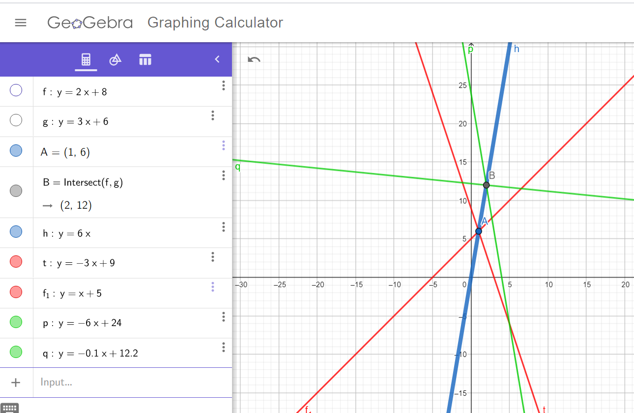

Na prethodnoj slici grafički se vidi ono što je maloprije prikazano algebarski. Samo kroz točku T(2,12) prolaze pravci zelene boje, pravac y=-6x+24. Za taj pravac vrijedi b=-6 i m=24. Ovi koeficijenti zadovoljavaju samo jednadžbu 2m+b-12=0.

I pravac y=-0.1x+12.2. Za taj pravac vrijedi b=-0.1 i m=12.2. Ovi koeficijenti zadovoljavaju samo jednadžbu 2m+b-12=0.

Samo kroz točku T(1, 6) prolaze pravci crvene boje, pravac y=-3x+9. Za taj pravac vrijedi b=-3 i m=9. Ovi koeficijenti zadovoljavaju samo jednadžbu m+b-6=0.

I pravac y=x+5. Za taj pravac vrijedi b=1 i m=5. Ovi koeficijenti zadovoljavaju samo jednadžbu m+b-6=0.

Kroz obje točke, točku T(2,12) i točku T(1,6) prolazi samo plavi pravac, pravac y=6x.

Koeficijenti ovog pravca su m=6 i b=0. Samo ovi koeficijenti zadovoljavaju obje jednadžbe, i jednadžbu 2m+b-12=0 i jednadžbu m+b-6=0.

Na slici iznad su u Houghovom prostoru prikazane b i m vrijednosti za pravce koji prolaze kroz točku u x,y koordinatnom sustavu. Tj. za pet primjera su prikazane koordinatne točke. Ako spojimo točke, zakjučujemo da je točka u x,y prostoru kroz koju prolazi beskonačan broj pravaca, predstavljena jednim pravcem u Houghovom prostoru.

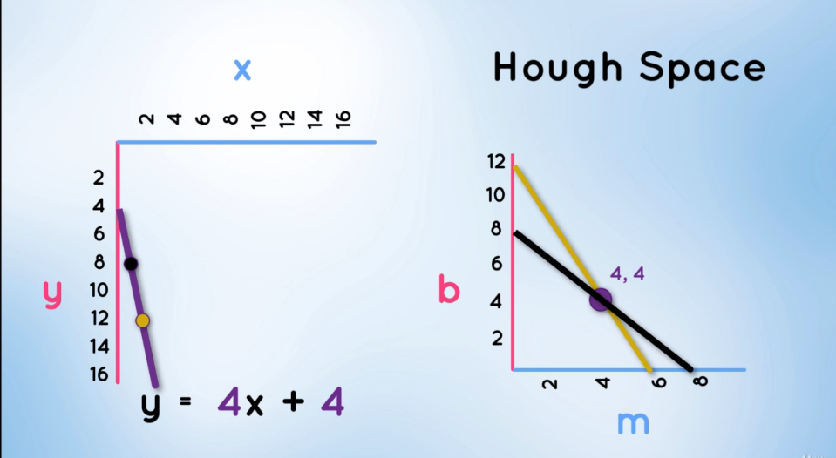

Ako u x,y prostoru imamo dvije točke kroz koje može prolaziti beskonačan broj pravaca, u Houghovom prostoru će beskonačan broj tih pravaca biti predstavljen po jednim pravcem za svaku točku.

U točki gdje se u Houghovom prostoru ta dva pravca sijeku, nalaze se vrijednosti m i b paramtetra za koje dobivamo pravac koji u x,y prostoru prolazi kroz obje točke.

Kako nam ovo služi? U crno-bijeloj slici, bijele crte su zapravo niz bijelih TOČAKA koje naš mozak automatski prepoznaje kao linije. Računalo to prepoznaje kao linije pomoću Houghovog prostora.



U x,y prostoru imamo niz točaka, tj. 4 točke, zamislimo da su to točke sa crno-bijele slike na kojoj je naš mozak odmah prepoznao linije.

Kroz svaku od četiri točke može proći beskonačan broj pravaca, i te četiri “beskonačnosti” su predstavljene pravcima u Houghovom prostoru. U Houghovom prostoru ne postoji zajedničko sjecište svih tih pravaca, što znači da ne postoji pravac koji u x,y prostoru prolazi kroz sve četiri točke.

No, postoji pravac čija je srednja kvadratna pogreška najmanja. Taj pravac dobijemo ako u Houghovom prostoru postavimo mrežu kvadrata određene rezolucije i dimenzija, i promatramo koji kvadrat u sebi sadrži najviše presjecišta pravaca. Za taj kvadrat izabiremo vrijednosti m i b i dobivamo “best fitting” pravac u x,y ravni.

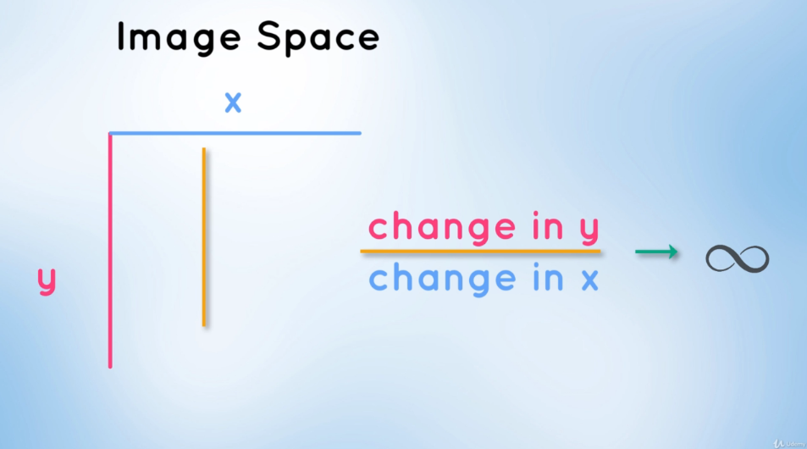Na gornjoj slici je prikazan problem sa vertikalnim linijama zbog kojeg se koristi Hueghov prostor ali u polarnim koordinatama.

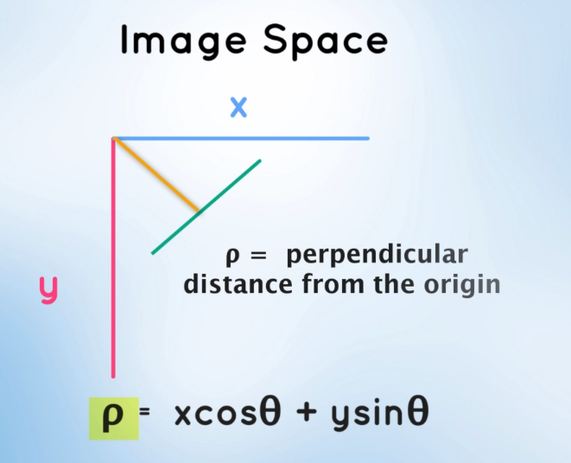

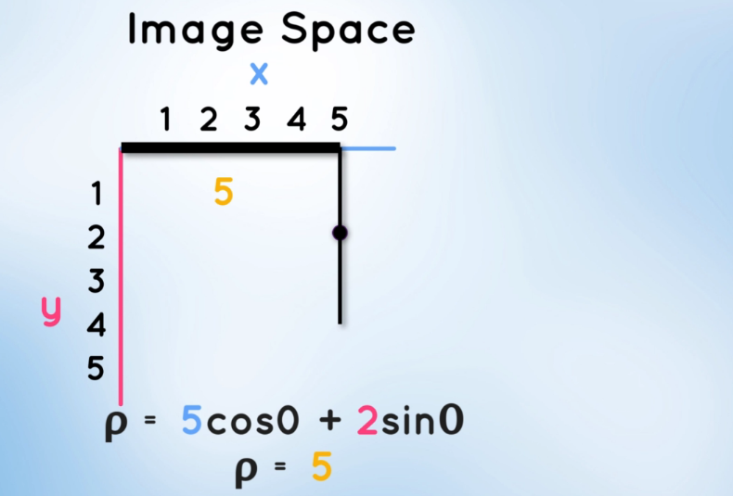

Ro je modul koji je okomit na pravac koji prolazi kroz neku točku. U ovom primjeru je prikazano kako sa polarnim koordinatama možemo raditi sa okomiti mpravcima.

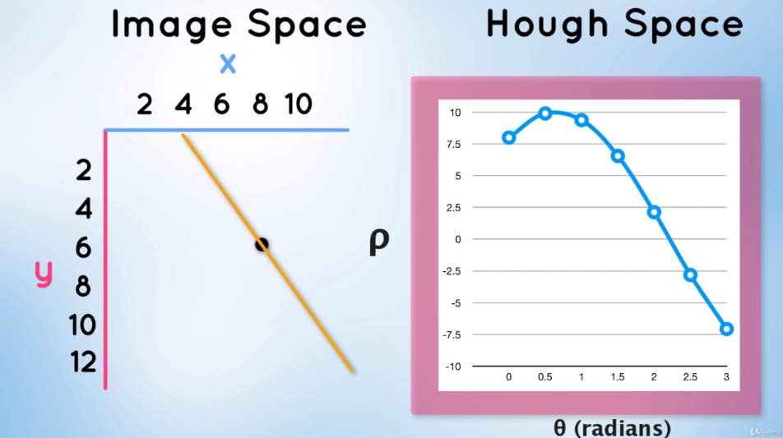

Za svaki kut theta, modul ima drugačiju vrijednost. Zato sada kreiramo Hoghov prostor kojemu su osi označene sa ro i theta, svaki pravac koji prolazi kroz neku točku u x,y prostoru je označen točkom u Houghovom prostoru ali ovaj put sa pripadnim r oi theta koordinatama.

Beskonačan broj pravaca koji u x,y prostoru prolazi kroz neku točku, u Houghovom prostoru sa polarnim koordinatama ne čini pravac kao u prethodnom slučaju, nego čini sinusoidu.

Ako imamo više točaka, imamo više sinusoida. Presjecište sinusoida nam govori za koje parameter r oi theta će neki pravac prolaziti kroz više točaka istodobno.

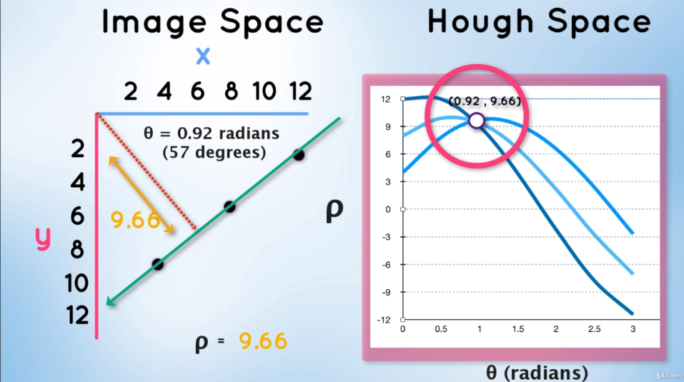

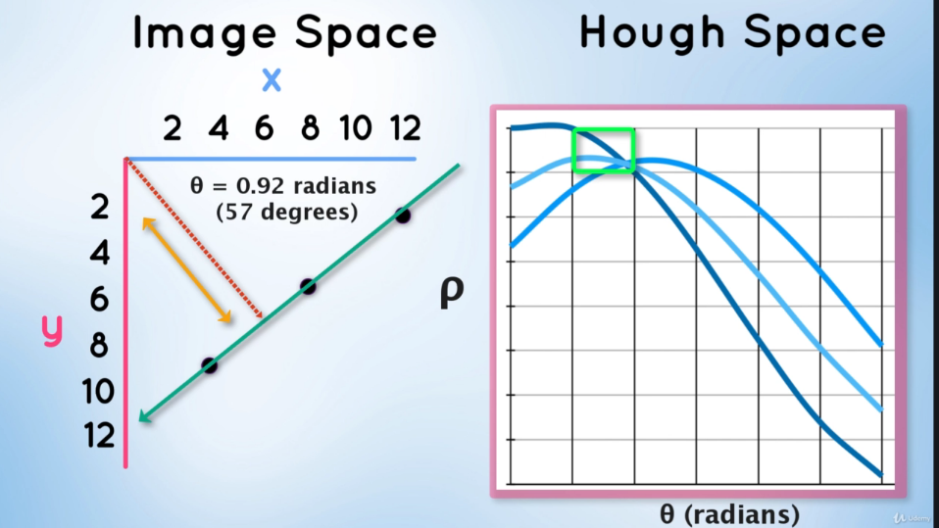

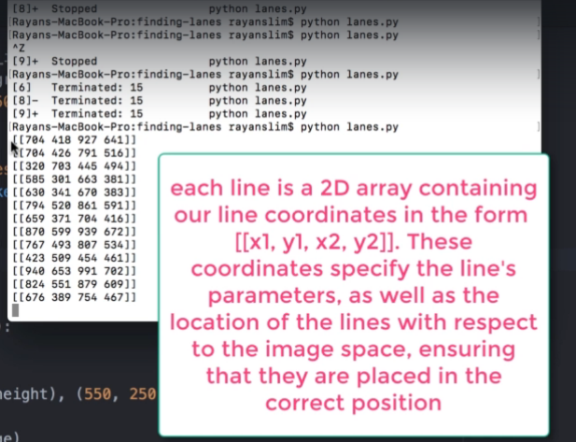

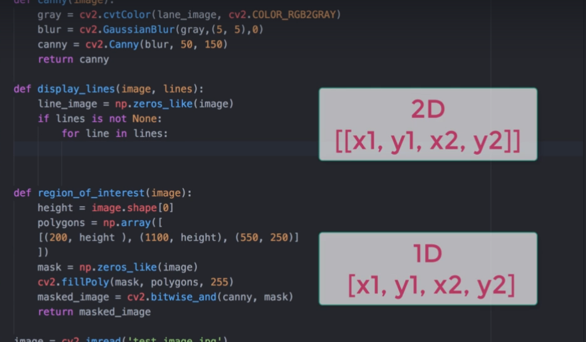

# 6) The Perceptron – 1h 31 min

**Ovo poglavle bolje shvatiti. Inače, komplicirani procesi ovog poglavlja se jednostavno rade pomoću Keras biblioteke (sljedeće poglavlje).**

**Jupyter Lab**: JupyterLab is a next-generation web-based user interface for Project Jupyter. JupyterLab enables you to work with documents and activities such as Jupyter notebooks, text editors, terminals, and custom components in a flexible, integrated, and extensible manner.

U Jupyter lab ulazim naredbom:

cd Desktop/

Jupyter lab

**Kreiram datoteku pod nazivom "Logistic Regression".** Cilj je formirati dva skupa podataka i podijeliti ih pomoću algoritma.

Kreiram nasumične vrijednosti po Gaussovoj distribuciji, sa središtem u 10 i standardnom devijacijom iznosa 2.

Ovo su vrijednosti za x1 varijable, tj. za horizontalnu os.

Dalje radim slično za x2 varijablu i onda kombiniram x1 i x2 pomoću array kako bi dobio

točke sa tim koordinatama i nakndno ih ucrtao na graf.

Na svaku od točaka trebam primijeniti sigmoidalnu funkciju, tj. sigmoidalni neuron koji daje vjerojatnosnu raspodjelu

da li neka točka. tj. neka osoba spada među bolesnike ili ne. Relativno na neki linearni model. Početna "step" funkcija govori samo Da, Ne.

**numpy.ones(shape, dtype=None, order='C')**

Return a new array of given shape and type, filled with ones.

Cilj mi je uz svaku kombinaciju x1 i x2 varijable ubaciti i bias vrijednost.

Kada ubacujem liniju razdvajanja, ona horizontalno treba ići od najmanje x koordinate

koja se pojavljuje do najveće x koordinate koja se pojavljuje.

Horizontalne vrijednosti su označene x1 varijablom a vertikalne x2 varijablom.

x1 = np.array([down_region[ : ,0].min(), top_region[ : ,0].max()])

x2 = -bias/w2+x1*(-w1/w2)

Liniju razdvajanja određujemo uz pomoć nasumično odabranih koeficijenata w1, w2 i bias.

Zatim uz pomoć sigmoidalne funkcije računam vjerojatnost da se neka točka nalazi na nebolesnoj strani.

To činim tako što primijenim sigmoidalnu funkciju na linearnu kombinaciju svih točaka koje imam.

Kod cross entropy, ukupnu pogrešku računamo kao sumu logaritamskih

vrijednosti svake pojedine pogreške. I to crvene moraju biti izražene kao vjerojatnost

da su crvene a plave kao vjerojatnost da su plave.

Pitanje: Na slici proračuna greške, zašto na oba modela vrijednosti nisu iste a samo linija drugačija?

Sada to primijenimo u kodu, za broj točaka iznosa 10 kreiram array od 1 stupca i 20 redaka, gdje je 10 redaka iznosa nula a 10 iznosa 1. Ovo koristim u funkciji za računanje ukupne pogreške.

Kod minimiziranja pogreške prvo računam njen gradijent tj. drivaciju po w1 i w2 varijabli.

# 7) Keras

Instaliram potrebne dodatke.

U jupyter labu kreiram dokument pod nazivom perceptron

from keras.models import Sequential:

**What is keras sequential?**

The Keras Python library makes creating deep learning models fast and easy. The sequential API allows you to create models layer-by-layer for most problems. It is limited in that it does not allow you to create models that share layers or have multiple inputs or outputs.

[**O Kerasu.**](https://keras.io/why-use-keras/)

Vršim instalacije:

* pip install tensorflow
* pip install keras

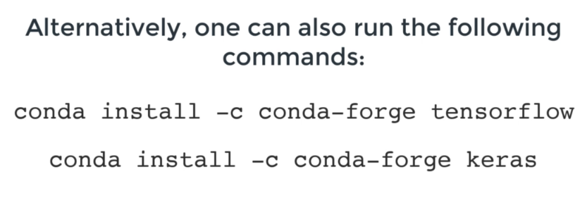

Primjer koda za treniranje mreže:

**model = Sequential()**

**model.add(Dense(units=1, input_shape=(2,), activation='sigmoid'))**

**adam=Adam(lr = 0.1 )**

**model.compile(adam, loss='binary_crossentropy', metrics=['accuracy'])**

**h=model.fit(x=X, y=y, verbose=1, batch_size=50,epochs=500, shuffle='true')**

**from keras.layers import Dense**

What is keras dense?

'Dense' is a name for a Fully connected / linear layer in keras. ... A CNN, in the convolutional part, will not have any linear (or in keras parlance - dense) layers.What is keras dense?

**model = Sequential() –** [**Objašnjenje.**](https://keras.io/getting-started/sequential-model-guide/)

[**Keras Model**](https://keras.io/getting-started/sequential-model-guide/)

The Sequential model is a linear [**stack**](https://hr.wikipedia.org/wiki/Stog) of layers.

You can create a Sequential model by passing a list of layer instances to the constructor:

**model.add(Dense(units=1, input_shape=(2,), activation='sigmoid')):** [**Objašnjenje Dense**](https://keras.io/layers/core/)

**keras.layers.Dense(units, activation=None, use_bias=True, kernel_initializer='glorot_uniform', bias_initializer='zeros', kernel_regularizer=None, bias_regularizer=None, activity_regularizer=None, kernel_constraint=None, bias_constraint=None)**

* **units**: Positive integer, dimensionality of the output space.
* **activation**: Activation function to use (see [activations](https://keras.io/activations/)). If you don't specify anything, no activation is applied (ie. "linear" activation: a(x) = x).
* **use_bias**: Boolean, whether the layer uses a bias vector.
* **kernel_initializer**: Initializer for the kernel weights matrix (see [initializers](https://keras.io/initializers/)).
* **bias_initializer**: Initializer for the bias vector (see [initializers](https://keras.io/initializers/)).
* **kernel_regularizer**: Regularizer function applied to the kernel weights matrix (see [regularizer](https://keras.io/regularizers/)).
* **bias_regularizer**: Regularizer function applied to the bias vector (see [regularizer](https://keras.io/regularizers/)).
* **activity_regularizer**: Regularizer function applied to the output of the layer (its "activation"). (see [regularizer](https://keras.io/regularizers/)).
* **kernel_constraint**: Constraint function applied to the kernel weights matrix (see [constraints](https://keras.io/constraints/)).
* **bias_constraint**: Constraint function applied to the bias vector (see [constraints](https://keras.io/constraints/)).

Dense implements the operation: output = activation(dot(input, kernel) + bias) where activation is the element-wise activation function passed as the activation argument, kernel is a weights matrix created by the layer, and bias is a bias vector created by the layer (only applicable if use_bias is True).

* Sada možemo dodavati slojeve u našu UNM.
* Pozivam Dense biblioteku i dodajem njene parametre.
* units = 1 označava broj izlaza ako sam dobro čuo, ostale članove moram dodati jer se radi o prvom sloju mreže.
* input_shape označava broj ulaznih čvorova, ovdje su dva, x1 i x2
* sigmoidal označava funkciju koju koriste čvorovi

**from keras.optimizers import Adam**:

An optimizer is one of the two arguments required for compiling a Keras model:

The parameters clipnorm and clipvalue can be used with all optimizers to control gradient clipping:

Adam optimizer.

Default parameters follow those provided in the original paper.

Arguments

learning_rate: float >= 0. Learning rate.

beta_1: float, 0 < beta < 1. Generally close to 1.

beta_2: float, 0 < beta < 1. Generally close to 1.

amsgrad: boolean. Whether to apply the AMSGrad variant of this algorithm from the paper "On the Convergence of Adam and Beyond".

keras.optimizers.Adam(learning_rate=0.001, beta_1=0.9, beta_2=0.999, amsgrad=False)

Ranije opisana metoda gradijentnog spusta koja je izražena formulom:

gradient = ((points.T*(p-y)*(alpha/m)

line_parameters=line_parameters-gradient

Ovakva metoda je previše računalno zahtijevna, jer "points" je argument koji se može mjeriti u milijardama.

Ukratko, proces računjanja najmanje pogreške je potencijalno predug, prezahtijevan. I to za samo jedan korak bi morao koristiti

sve milijarde podataka. **Zato se koristi stohastic gradient descent**.

Stohastički koristi jedan manji, nasumično odabran set podataka, za računanje greške.

Adam stohastička metoda je kombinacija Adagrad i RMSprop metoda optimizacije.

**Adam metoda sama računa povoljan stupanj učenja tijekom trajanja procesa računanja i mijenja ga. Zato je odlična.**

**model.compile(adam, loss='binary_crossentropy', metrics=['accuracy'])**

**compile(optimizer, loss=None, metrics=None, loss_weights=None, sample_weight_mode=None, weighted_metrics=None, target_tensors=None**)

Configure a Keras model for training

[**Parametri treniranja modela**](https://keras.io/models/model/):

1) adam: metoda optimizacije

2) 'binary_crossentropy': računa crossentropy vrijednost za binarne probleme (DA ili NE), ako imamo više problema, koristimo "cathegorical crossentropy"

3) metrics=['accuracy']: ne služi za treniranje mreže nego za ocjenu kvalitete rezulta nakon svake epohe. Može se koristiti i MSE itd.

* **optimizer**: String (name of optimizer) or optimizer instance. See [optimizers](https://keras.io/optimizers).
* **loss**: String (name of objective function) or objective function or Loss instance. See [losses](https://keras.io/losses). If the model has multiple outputs, you can use a different loss on each output by passing a dictionary or a list of losses. The loss value that will be minimized by the model will then be the sum of all individual losses.
* **metrics**: List of metrics to be evaluated by the model during training and testing. Typically you will use metrics=['accuracy']. To specify different metrics for different outputs of a multi-output model, you could also pass a dictionary, such as metrics={'output_a': 'accuracy', 'output_b': ['accuracy', 'mse']}. You can also pass a list (len = len(outputs)) of lists of metrics such as metrics=[['accuracy'], ['accuracy', 'mse']] or metrics=['accuracy', ['accuracy', 'mse']].
* **loss_weights**: Optional list or dictionary specifying scalar coefficients (Python floats) to weight the loss contributions of different model outputs. The loss value that will be minimized by the model will then be the weighted sum of all individual losses, weighted by the loss_weights coefficients. If a list, it is expected to have a 1:1 mapping to the model's outputs. If a dict, it is expected to map output names (strings) to scalar coefficients.
* **sample_weight_mode**: If you need to do timestep-wise sample weighting (2D weights), set this to "temporal". None defaults to sample-wise weights (1D). If the model has multiple outputs, you can use a different sample_weight_mode on each output by passing a dictionary or a list of modes.
* **weighted_metrics**: List of metrics to be evaluated and weighted by sample_weight or class_weight during training and testing.
* **target_tensors**: By default, Keras will create placeholders for the model's target, which will be fed with the target data during training. If instead you would like to use your own target tensors (in turn, Keras will not expect external Numpy data for these targets at training time), you can specify them via the target_tensors argument. It can be a single tensor (for a single-output model), a list of tensors, or a dict mapping output names to target tensors.
* **\*\*kwargs**: When using the Theano/CNTK backends, these arguments are passed into K.function. When using the TensorFlow backend, these arguments are passed into tf.Session.run.

**h=model.fit(x=X, y=y, verbose=1, batch_size=50,epochs=500, shuffle='true')**

**fit**: Trains the model for a fixed number of epochs (iterations on a dataset).

***Pojasni si malo način treniranja. Kako određujemo način treniranja? Ili funkcija sama izabire način na temelju dostupnih parametara?***

Parametri:

* x=X: Prvo proslijđujemo podatke i njihovu oznaku
* y=y: Prvo proslijđujemo podatke i njihovu oznake. Da se zna koji podatak pripada kojoj klasi.
* verbose=1: verbose: Integer - 0, 1, or 2. Verbosity mode. 0 = silent, 1 = progress bar, 2 = one line per epoch. Kada bi stavili 0, ne bi znali što se događa.
* batch_size=50: podjela podataka na podskupove za treniranje
* epochs=500: jedna iteracija svih podataka, koje se dijele u 50 batch size komada. Broj epoha ne smije biti ni prevelik ni premalen. Overfitting/underfitting
* shuffle='true': miješa svaki put iznova trening podatke kako se ne bi zaglavljivali na istom lokalnom minimumu prilikom traženja pogreške

Poslije je pomoću numpy-a napravljeno grafičko sučelje na kojemo prikazujemo podatke istrenirane mreže. Za model koji je opisiv

jednostavnom linearnom funkcijom i za kompleksniji model. Principi su isti, razlika je u korištenju pripdnih funkcija itd.

Detaljnije:

**plt.scatter(X[:n_pts,0], X[:n_pts,1])**

**plt.scatter(X[n_pts:,0], X[n_pts:,1]) - PROUČI OVU FUNKCIJU I NJEN ZAPIS, ARGUMENTE**

**plot(h.history['accuracy'])**

**numpy.linspace(start, stop, num=50, endpoint=True, retstep=False, dtype=None, axis=0)**

Return evenly spaced numbers over a specified interval.

Returns num evenly spaced samples, calculated over the interval [start, stop].

The endpoint of the interval can optionally be excluded.

**numpy.c_ = <numpy.lib.index_tricks.CClass object>**

Translates slice objects to concatenation along the second axis.

This is short-hand for np.r_['-1,2,0', index expression], which is useful because of its common occurrence. In particular, arrays will be stacked along their last axis after being upgraded to at least 2-D with 1’s post-pended to the shape (column vectors made out of 1-D arrays).

predict(x, batch_size=None, verbose=0, steps=None, callbacks=None, max_queue_size=10, workers=1, use_multiprocessing=False)

Generates output predictions for the input samples.

Computation is done in batches.

**plt.plot([x], [y], marker='o', markersize=10, color="red")**

# 8) Deep Neural Networks 101 – 44 min

**import numpy as np**

**import matplotlib.pyplot as plt**

**from sklearn import datasets - služi za ubacivanje složenijih oblika podataka**

**import keras**

**from keras.models import Sequential**

**from keras.layers import Dense**

**from keras.optimizers import Adam**

**sklearn.datasets.make_circles(n_samples=100, shuffle=True, noise=None, random_state=None, factor=0.8)**

**X, y = datasets.make_circles(n_samples=n_pts, random_state = 123, noise=0.1, factor=0.2)**

[**Objašnjenje datasets.make_circles**](https://scikit-learn.org/stable/modules/generated/sklearn.datasets.make_circles.html)

Make a large circle containing a smaller circle in 2d.

A simple toy dataset to visualize clustering and classification algorithms.

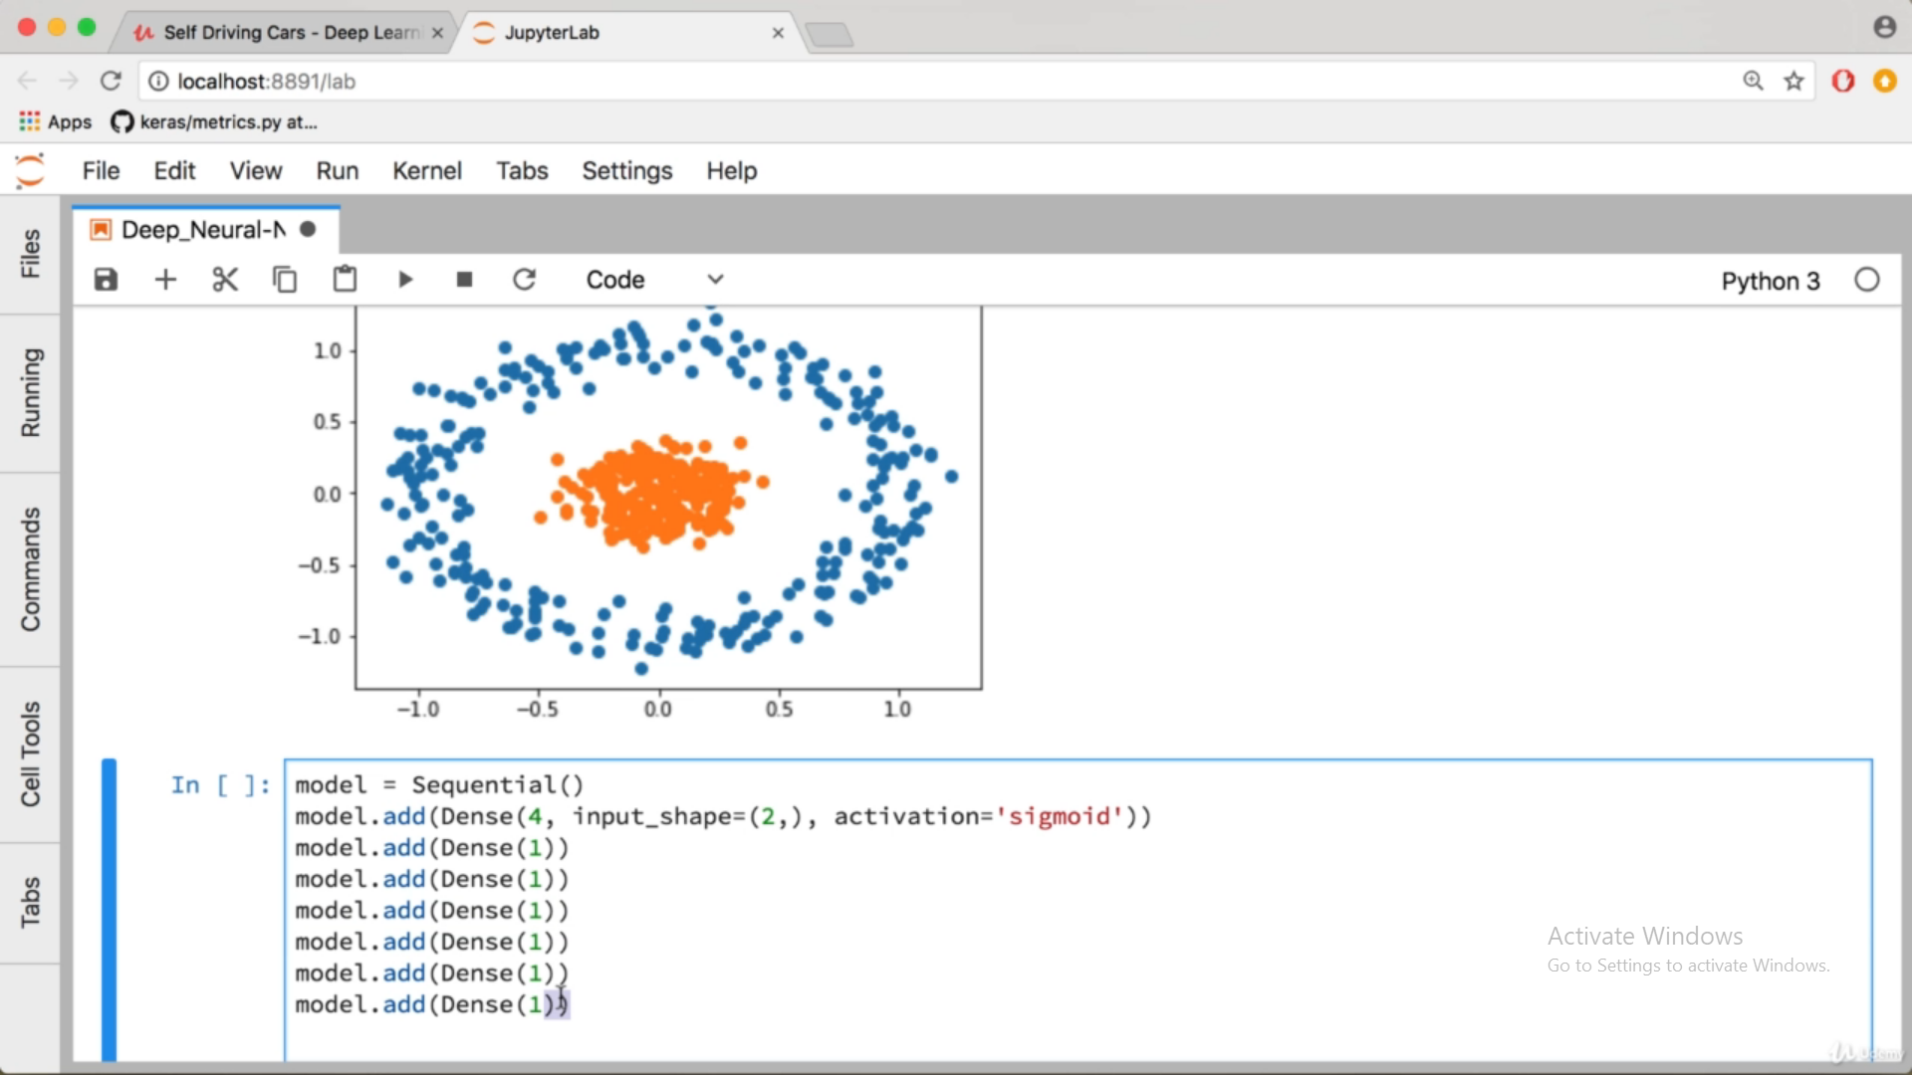

# 9) Multiclass Classification – 53 min

Kako bih klasificirao više od dva različita skupa podataka, koristim se **Softmax** aktivacijskom funkcijom.

Skupove ne mogu označavati sa 0,1,2 jer tada algoritam pretpostavlja da su skupovi međusobno ovisni.

Zato ih označavam kao 001, 010, 100.

**from keras.utils.np_utils import to_categorical**

**X, y = datasets.make_blobs(n_samples=n_pts, random_state = 123, centers=centers, cluster_std=0.4)**

Generate isotropic Gaussian blobs for clustering.

Read more in the User Guide.

[**Blobs**](https://scikit-learn.org/stable/modules/generated/sklearn.datasets.make_blobs.html)

[**Sample generators**](https://scikit-learn.org/stable/datasets/index.html#sample-generators)

**y_cat = to_categorical(y, 5)**

Converts a class vector (integers) to binary class matrix.

E.g. for use with categorical_crossentropy.

**Arguments**

* **y**: class vector to be converted into a matrix (integers from 0 to num_classes).
* **num_classes**: total number of classes.
* **dtype**: The data type expected by the input, as a string (float32, float64, int32...)

**Returns**

A binary matrix representation of the input. The classes axis is placed last.

**n_pts = 500**

* centers = [[-1, 1], [-1, -1], [1, -1], [1, 1], [0, 0]] #središta klastera podataka. Na početku je stavio samo tri.
* X, y = datasets.make_blobs(n_samples=n_pts, random_state = 123, centers=centers, cluster_std=0.4) #Kreiram dataset i oznake
* #n_sampels - broj točaka
* #Omogućuje reproduciranja istog random data seta
* #centers - referiramo se na kreiranu varijablu centers koja označva centre klastera
* #cluster_std - ako sam dobro shvatio, namještamo raširenost podataka

**plt.scatter(X[y==0, 0], X[y==0, 1])**

**plt.scatter(X[y==1, 0], X[y==1, 1])**

**plt.scatter(X[y==2, 0], X[y==2, 1])**

**plt.scatter(X[y==3, 0], X[y==3, 1])**

**plt.scatter(X[y==4, 0], X[y==4, 1]) #Prethodnih pet linija dohvaćaju i na graf ucrtavaju pet različtih klastera podataka.**

**print(y)**

**y_cat = to_categorical(y, 5) #oznake i broj klastera**

**#Kao što se ispod vidi, ova funkcija kodira prvotne oznake za klastere.**

**#Pa je 3 => [0. 0. 0. 1. 0.]**

**print(y_cat)**

**model.predict_classes(point)**

**def plot_multiclass_decision_boundary(X, y, model):**

**x_span = np.linspace(min(X[:,0]) - 1, max(X[:,0]) + 1)**

**y_span = np.linspace(min(X[:,1]) - 1, max(X[:,1]) + 1)**

**xx, yy = np.meshgrid(x_span, y_span)**

**grid = np.c_[xx.ravel(), yy.ravel()]**

**pred_func = model.predict_classes(grid)**

**z = pred_func.reshape(xx.shape)**

**plt.contourf(xx, yy, z)**

**plot_multiclass_decision_boundary(X, y_cat, model)**

**plt.scatter(X[y==0, 0], X[y==0, 1])**

**plt.scatter(X[y==1, 0], X[y==1, 1])**

**plt.scatter(X[y==2, 0], X[y==2, 1])**

**plt.scatter(X[y==3, 0], X[y==3, 1])**

**plt.scatter(X[y==4, 0], X[y==4, 1])**

**x = -0.5**

**y = -0.5**

**point = np.array([[x, y]])**

**prediction = model.predict_classes(point)**

**plt.plot([x], [y], marker='o', markersize=10, color="white")**

**print("Prediction is: ", prediction)**

# 10) MNIST Image Recognition – 1h 34 min

The MNIST database of handwritten digits, available from this page, has a training set of 60,000 examples, and a test set of 10,000 examples. It is a subset of a larger set available from NIST. The digits have been size-normalized and centered in a fixed-size image.

It is a good database for people who want to try learning techniques and pattern recognition methods on real-world data while spending minimal efforts on preprocessing and formatting.

**assert <condition>,<error message>**

In Python we can use assert statement in two ways as mentioned above.

assert statement has a condition and if the condition is not satisfied the program will stop and give AssertionError.

assert statement can also have a condition and a optional error message. If the condition is not satisfied assert stops the program and gives AssertionError along with the error message.

**assert(X_train.shape[0] == y_train.shape[0]), "The number of images is not equal to the number of labels."**

**assert(X_test.shape[0] == y_test.shape[0]), "The number of images is not equal to the number of labels."**

**assert(X_train.shape[1:] == (28,28)), "The dimensions of the images are not 28x28"**

**assert(X_test.shape[1:] == (28,28)), "The dimensions of the images are not 28x28"**

**fig, axs = plt.subplots(nrows=num_classes, ncols = cols, figsize=(5, 8))** #Subplot omogućuje crtanje više sika na jednu

[**Subplots**](https://matplotlib.org/3.1.1/api/_as_gen/matplotlib.pyplot.subplots.html)

**for i in range(cols):**

**for j in range(num_classes):**

**x_selected = X_train[y_train == j]**

**axs[j][i].imshow(x_selected[random.randint(0, len(x_selected - 1)), :, :], cmap=plt.get_cmap("gray"))**

**axs[j][i].axis("off")**

**if i == 2:**

**axs[j][i].set_title(str(j))**

**num_of_samples.append(len(x_selected))**

*Prouči značenje onih grafova

**score = model.evaluate(X_test, y_test, verbose=0)**

**evaluate(x=None, y=None, batch_size=None, verbose=1, sample_weight=None, steps=None, callbacks=None, max_queue_size=10, workers=1, use_multiprocessing=False)**

Returns the loss value & metrics values for the model in test mode.

**response = requests.get(url, stream=True)**

One of the most common HTTP methods is GET. The GET method indicates that you’re trying to get or retrieve data from a specified resource. To make a GET request, invoke requests.get().

**response.raw** - prouči

**import cv2**

**img = np.asarray(img) #Konvertira ulazne podatke u array**

**img = cv2.resize(img, (28, 28)) #Mijenjamo veličinu slike**

**img = cv2.cvtColor(img, cv2.COLOR_BGR2GRAY) #Pretvaramo je u crno-bijelu sliku**

**img = cv2.bitwise_not(img) #Pretvaramo sve nule u 255 i obrnuto. Tako da dobijemo bijli broj na crnoj podlozi - kao i kod prijašnih brojeva.**

**plt.imshow(img, cmap=plt.get_cmap('gray'))**

https://daftsex.com/watch/-126044809_456239107

Computation is done in batches.

# 11) Convolutional Neural Networks

Konvolucijske neuralne mreže služe za klasifikaciju slika. Imaju mnogo prednosti u odnosu na klasične neuralne mreže. Konvolucijske NN koriste informacije o prostornom rasproedu piksela, za razliku od klasičnih NN. Što ovo znači?

KNN zahtijevaju manje parametara od klasičnih NN.

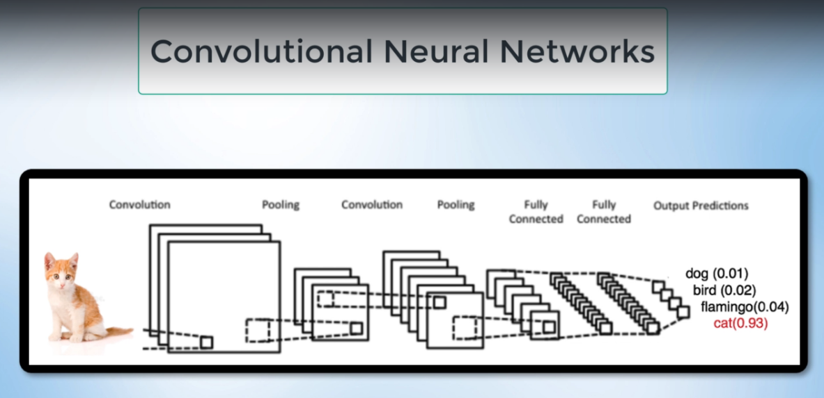

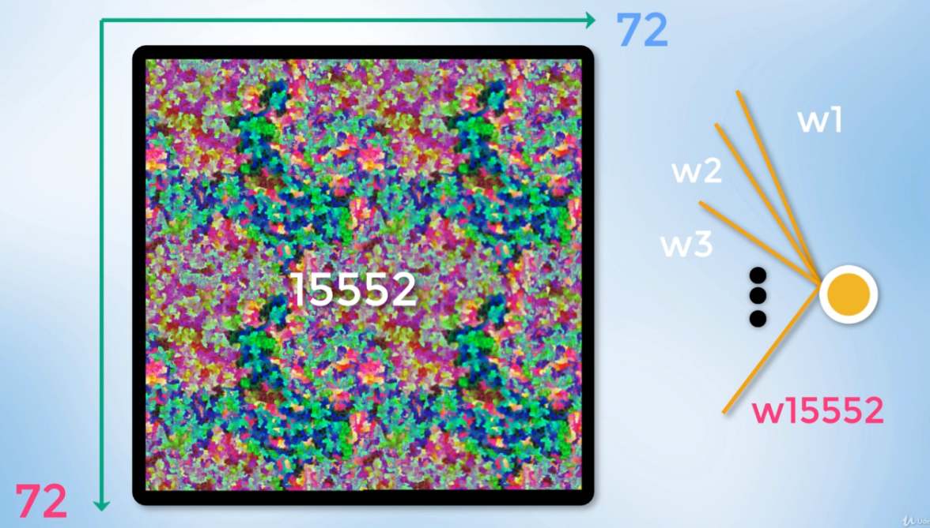

Klasičnim NN mrežama je lako obrađivati slike koje su ranije obrađivane, sa malim dimenzijama (28x28) i samo jednim kanalom boja. Ukoliko smo prisiljeni koristiti slike u boji (4 kanala) i većih dimenzija, npr. 72x72 piksela, dobijemo da svaki neuron u prvom skrivenom sloju ima 15552 veze. Očito je da su ovakve mreže računalno izuzetno zahtijevne. Konvolucijske NN rješavaju ovaj problem.

Također, konvolucijske NN pomoću “pooling” slojeva se bolje nose sa problemom “overfittinga”.

Konvolucijski sloj jedan je od glavnih dijelova svake konvolucijske neuronske mreže.

Svaki konvolucijski sloj sastoji se od filtara koje sadrže težine koje je potrebno nauˇciti

kako bi mreža davala dobre rezultate. Filtri su najˇceš´ce manjih prostornih dimenzija

od ulaza, no uvijek su jednake dubine kao i ulaz. Tako ako se na primjer na ulazu

konvolucijskog sloja nalazi slika s tri komponente boja (RGB) i veliˇcine je 25x25 to-

ˇcaka, filtar može biti matrica težina veliˇcine 5x5, ali potrebno je imati tri takve matrice,

odnosno jednu za svaku komponentu boje.

Slojevi sažimanja ˇcesto se koriste u konvolucijskim neuronskim mrežama nakon nekoliko

konvolucijskih slojeva s ciljem smanjivanja rezolucije mapi. Osim smanjivanja

rezolucije slojevi sažimanja pove´cavaju prostornu invarijantnost (neosjetljivost na manje

pomake znaˇcajki u uzorku) neuronske mreže [5].

Kao i kod konvolucijskog sloja manji dio uzorka grupira se i obrad¯uje se, te rezultira

jednom vrijednoš´cu. Postoji nekoliko vrsta sažimanja. Najˇceš´ci naˇcini su sažimanje

usrednjavanjem i sažimanje maksimalnom vrijednosti. Kod sažimanja usrednjavanjem

grupirani podaci zamjenjuju se aritmetiˇckom sredinom grupiranih vrijednosti,

dok se kod sažimanja maksimalnom vrijednosti grupirane vrijednosti zamjenjuju maksimalnom

vrijednoš´cu. Važno je uoˇciti kako broj komponenata (dubina) prije sloja

sažimanja i nakon sažimanja ostaje isti.

Pitanje: First Guess, Second Guess problem. Second Guess nekada nema veze sa sličnošću sa pravim brojem.

**127)** Krećemo sa Le Net arhitekturom CNN, čija je primarna svrha prepoznavanje brojeva na čekovima i koristi se od 1998. Već je ranije prikazana, tj. njeni slojevi.

**model.add(Conv2D(30, (5, 5), input_shape=(28, 28, 1), activation='relu'))**

[**Conv2d objašnjenje**](https://keras.io/layers/convolutional/)

Dodatni argumenti mogu biti strides – pomak kernela. I padding – zadržavanje ruba slike.

**11:00**

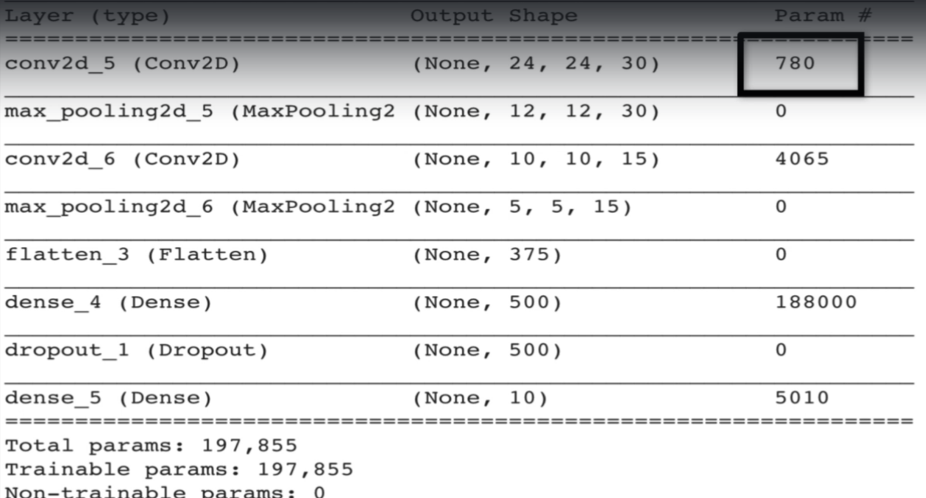

19:40 – objašnjenje za flatten.

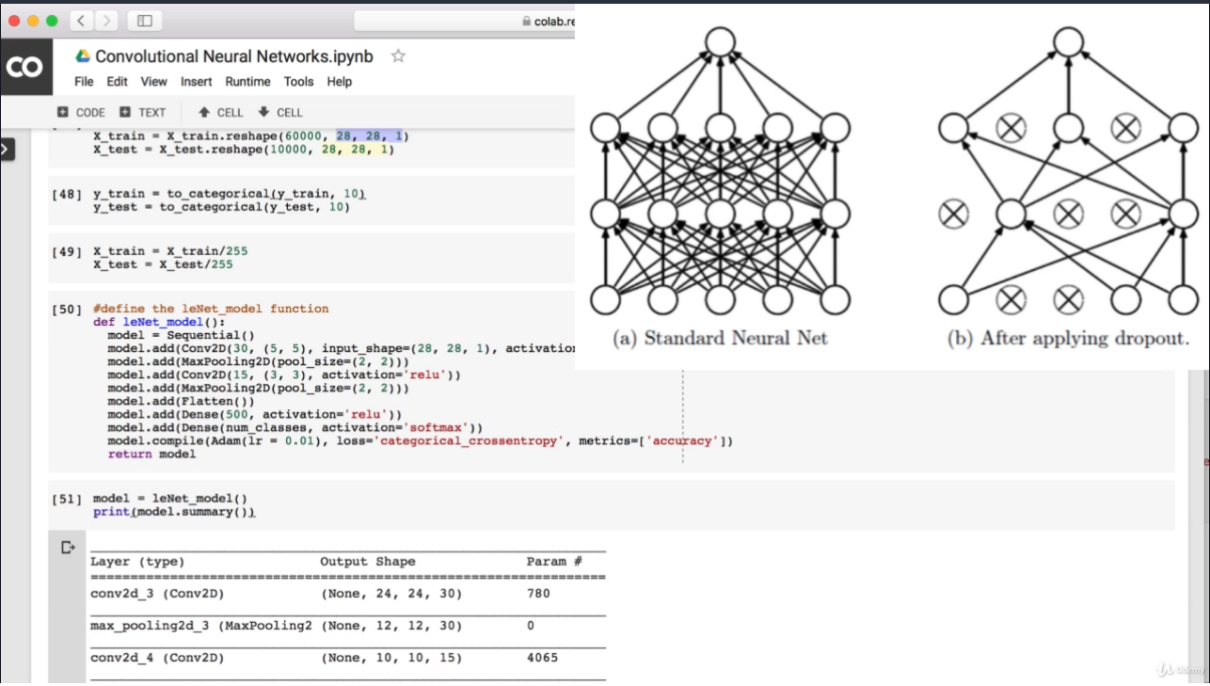

Dropout u svakom procesu treniranja isključuje nasumično odabrane neurone i tako prisiljava mrežu da traži rješenja sa uvijek različitim rasporedom neurona. Ovo pomaže kod sprječavanja overfittinga. Dropout možemo koristiti na raznim mjestima, najčešće se koriste između slojeva sa velikim brojem parametara.

# 12) Classifying Road Symbols – 1h 53 min

[**Objašnjenje pojma Pickeling.**](https://docs.python.org/3/library/pickle.html)

[**with**](https://www.geeksforgeeks.org/with-statement-in-python/)ključni pojam – koristi se kada želimo izvršiti dvije operacije istodobno i imamo komad koda između njih.

Problem sa identifikacijom znakova je prije svega u nedostatku podataka.

Model se programira po istom principu kao i ranije, prvo se odradi “preprocessing” slika, zatim se programira konvolucijski model za treniranje, nakon toga u model ubacujemo neke slike s internet i testiramo koliko je model precizan u pogađanju.

Preciznost pogađanja znakova nije impresivna zbog niza razloga. Prije svega, mnogi znakovi iz različitih klasa su međusobno vrlo slični. Problem djelomično rješavamo modificiranjem parametara mreže.  
  
Bolje rješenje je “Fit generator”. Ovo je metoda pomoću koje “sami” modificiramo već postojeće znakove. Modificiramo ih zumiranjem, rotiranjem, pomicanjem itd., i tako sami nadopunjujemo klase sa novim slikama koje se dalje koriste za treniranje mreže.

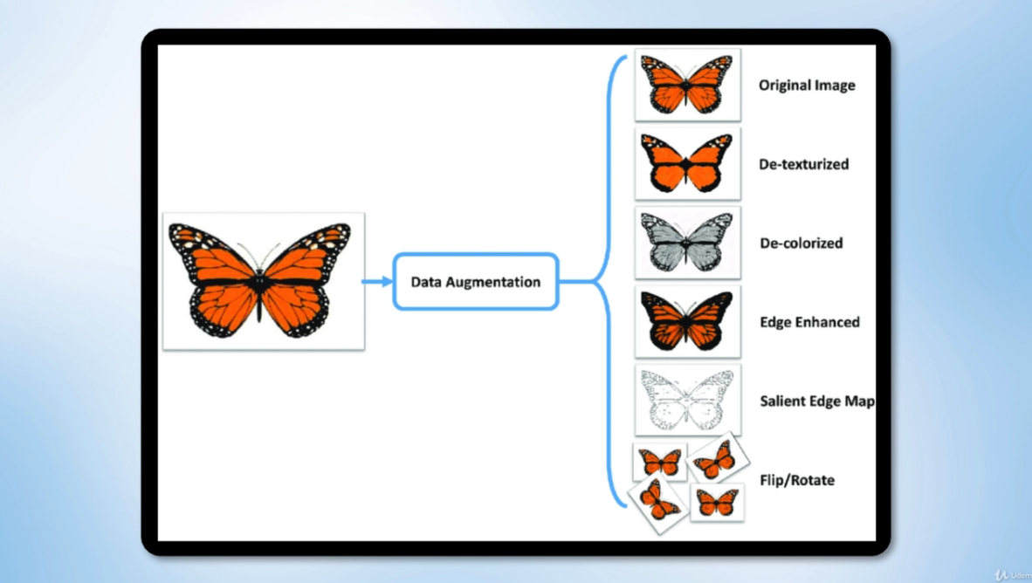

[**Preprocessing**](https://keras.io/preprocessing/image/)

**keras.preprocessing.image.ImageDataGenerator(featurewise_center=False, samplewise_center=False, featurewise_std_normalization=False, samplewise_std_normalization=False, zca_whitening=False, zca_epsilon=1e-06, rotation_range=0, width_shift_range=0.0, height_shift_range=0.0, brightness_range=None, shear_range=0.0, zoom_range=0.0, channel_shift_range=0.0, fill_mode='nearest', cval=0.0, horizontal_flip=False, vertical_flip=False, rescale=None, preprocessing_function=None, data_format='channels_last', validation_split=0.0, interpolation_order=1, dtype='float32')**

**Arguments**

* **featurewise_center**: Boolean. Set input mean to 0 over the dataset, feature-wise.
* **samplewise_center**: Boolean. Set each sample mean to 0.
* **featurewise_std_normalization**: Boolean. Divide inputs by std of the dataset, feature-wise.
* **samplewise_std_normalization**: Boolean. Divide each input by its std.
* **zca_epsilon**: epsilon for ZCA whitening. Default is 1e-6.
* **zca_whitening**: Boolean. Apply ZCA whitening.
* **rotation_range**: Int. Degree range for random rotations.
* **width_shift_range**: Float, 1-D array-like or int
  + float: fraction of total width, if < 1, or pixels if >= 1.
  + 1-D array-like: random elements from the array.
  + int: integer number of pixels from interval (-width_shift_range, +width_shift_range)
  + With width_shift_range=2 possible values are integers [-1, 0, +1], same as with width_shift_range=[-1, 0, +1], while with width_shift_range=1.0 possible values are floats in the interval [-1.0, +1.0).
* **height_shift_range**: Float, 1-D array-like or int
  + float: fraction of total height, if < 1, or pixels if >= 1.
  + 1-D array-like: random elements from the array.
  + int: integer number of pixels from interval (-height_shift_range, +height_shift_range)
  + With height_shift_range=2 possible values are integers [-1, 0, +1], same as with height_shift_range=[-1, 0, +1], while with height_shift_range=1.0 possible values are floats in the interval [-1.0, +1.0).
* **brightness_range**: Tuple or list of two floats. Range for picking a brightness shift value from.
* **shear_range**: Float. Shear Intensity (Shear angle in counter-clockwise direction in degrees)
* **zoom_range**: Float or [lower, upper]. Range for random zoom. If a float, [lower, upper] = [1-zoom_range, 1+zoom_range].
* **channel_shift_range**: Float. Range for random channel shifts.
* **fill_mode**: One of {"constant", "nearest", "reflect" or "wrap"}. Default is 'nearest'. Points outside the boundaries of the input are filled according to the given mode:
  + 'constant': kkkkkkkk|abcd|kkkkkkkk (cval=k)
  + 'nearest': aaaaaaaa|abcd|dddddddd
  + 'reflect': abcddcba|abcd|dcbaabcd
  + 'wrap': abcdabcd|abcd|abcdabcd
* **cval**: Float or Int. Value used for points outside the boundaries when fill_mode = "constant".
* **horizontal_flip**: Boolean. Randomly flip inputs horizontally.
* **vertical_flip**: Boolean. Randomly flip inputs vertically.
* **rescale**: rescaling factor. Defaults to None. If None or 0, no rescaling is applied, otherwise we multiply the data by the value provided (after applying all other transformations).
* **preprocessing_function**: function that will be applied on each input. The function will run after the image is resized and augmented. The function should take one argument: one image (Numpy tensor with rank 3), and should output a Numpy tensor with the same shape.
* **data_format**: Image data format, either "channels_first" or "channels_last". "channels_last" mode means that the images should have shape (samples, height, width, channels), "channels_first" mode means that the images should have shape (samples, channels, height, width). It defaults to the image_data_format value found in your Keras config file at ~/.keras/keras.json. If you never set it, then it will be "channels_last".
* **validation_split**: Float. Fraction of images reserved for validation (strictly between 0 and 1).
* **dtype**: Dtype to use for the generated arrays.

# 13) Polynomial Regression - 17 min

# 14) Behavioural Cloning

U ovom dijelu prvo kreiram skup podataka koje ću koristiti prilikom treniranja mreže. Kreiram ga tako što snimam vlastitu vožnju po nekoj stazi, te se ta snimka koristi kako bi mreža naučila voziti po nekoj novoj stazi.

Potrebno se spojiti na github, te učitati podatke u google colab. Tu mi se javio neki problem.

**import pandas as pd**

Python Data Analysis Library

[**Pandas**](https://pandas.pydata.org/)is an open source, BSD-licensed library providing high-performance, easy-to-use data structures and data analysis tools for the [Python](https://www.python.org/) programming language.

[**pd.read_csv()**](https://pandas.pydata.org/pandas-docs/stable/reference/api/pandas.read_csv.html)

[**pandas.set_option()**](https://pandas.pydata.org/pandas-docs/stable/reference/api/pandas.set_option.html)

[**os.path.join()**](https://www.geeksforgeeks.org/python-os-path-join-method/)**: OS module** in Python provides functions for interacting with the operating system. **os.path** module is sub-module of OS module in Python used for common pathname manipulation.

***os.path.join()*** method in Python join one or more path components intelligently. This method concatenates various path components with exactly one directory separator (‘/’) following each non-empty part except the last path component.

**data = pd.read_csv(os.path.join(datadir, 'driving_log.csv'), names = columns)**

**pd.set_option('display.max_colwidth', -1)**

**import ntpath**: This module provides [**os.path**](https://effbot.org/librarybook/os-path.htm) functionality on Windows platforms. You can also use it if you need to handle Windows paths on other platforms.

**ntpath.split()**

[**pandas.DataFrame.head**](https://pandas.pydata.org/pandas-docs/stable/reference/api/pandas.DataFrame.head.html) **; data.head()**

This function returns the first n rows for the object based on position. It is useful for quickly testing if your object has the right type of data in it.

**148)**

**149)** X_train, X_valid, y_train, y_valid = train_test_split(image_paths, steerings, test_size=0.2, random_state=6) #Split arrays or matrices into random train and test subsets

**150)**

**151) nVidia NN model koristimo zato jer je pomoću njega lakše formirati NN mreže sa kompleksnim podacima, kao što su ovi podaci za autonomnu vožnju.**

[**End-To-End Learning**](https://devblogs.nvidia.com/deep-learning-self-driving-cars/)

[**Dying relu**](https://datascience.stackexchange.com/questions/5706/what-is-the-dying-relu-problem-in-neural-networks)

**152)v153)**

[**Flask**](https://en.wikipedia.org/wiki/Flask_(web_framework))

**Što je conda envirionment?**

[**socketio**](https://en.wikipedia.org/wiki/Socket.IO)

**154) Potrebno je simulatoru proslijediti podatke o upravljanju iz našeg UNM modela**

**Pozabavi se neuspješnim instalacijama i pizdarijama.**

**155) Pokazalo se da se vozilo donekle dobro ponaša na stazi na kojoj je trenirano. Ali jako lose na novoj stazi. Jedan od razloga za to je mal broj podataka, koje treba prošiti augmentacijom.**

[**imgaug**](https://imgaug.readthedocs.io/en/latest/) **– bibilioteka za augmentaciju**

[iaa.Affine](https://imgaug.readthedocs.io/en/latest/source/api_augmenters_geometric.html)(scale=(1, 1.3))

 image = zoom.augment_image(image)

Augmentaciju ne primjenjujemo na svaku sliku nego na nasumičan broj njih. Primjena na svaku apravo smanjuje kvalitetu podataka. Zašto?

**156) Batch generator je u svrsi uštede memorije. To je funkcija pomoću koje augmentiramo mali broj slika odjednom samo onda kada je to potrebno/izravno naređeno, ako sam dobro shvatio.**

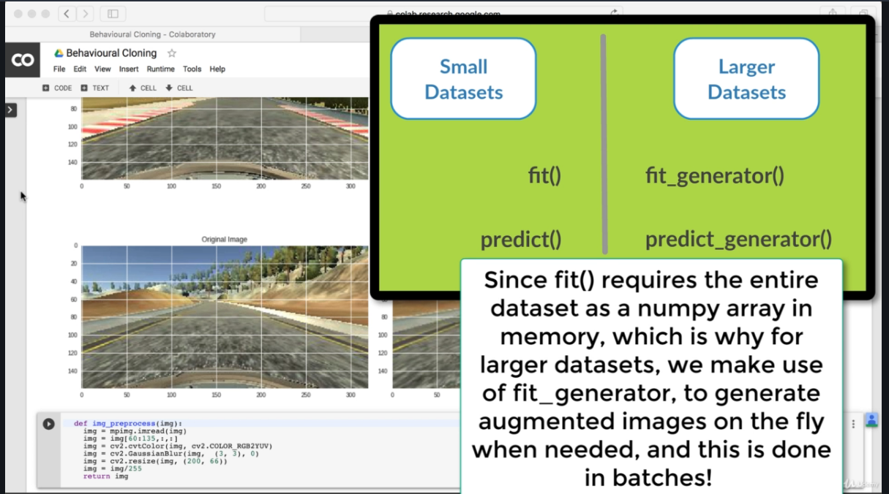

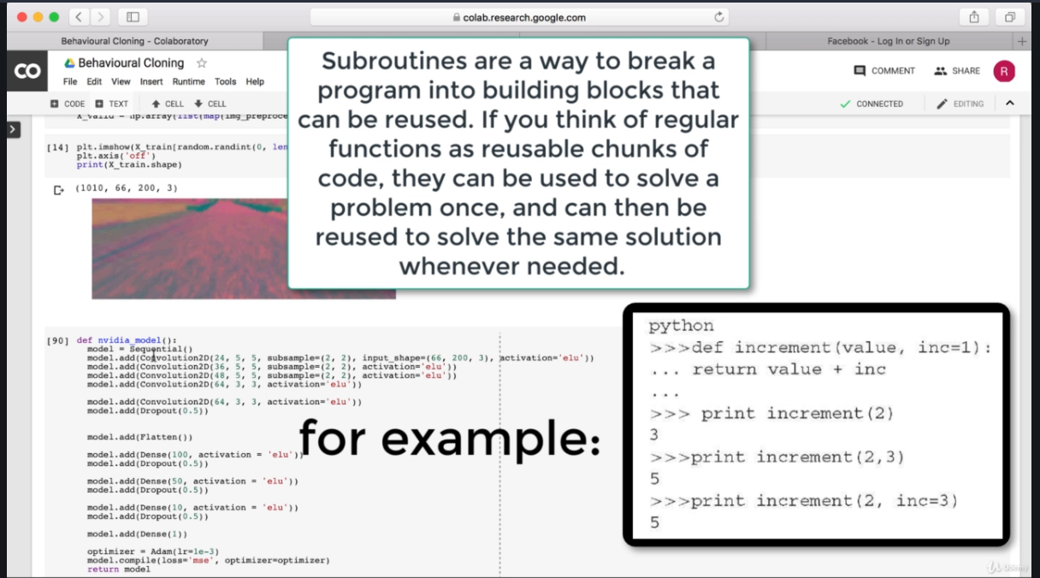

[**yield keyword**](https://www.google.com/search?q=yield+python&oq=yield+pyt&aqs=chrome.0.0j69i57j0l6.6300j0j7&sourceid=chrome&ie=UTF-8)

**157)**

